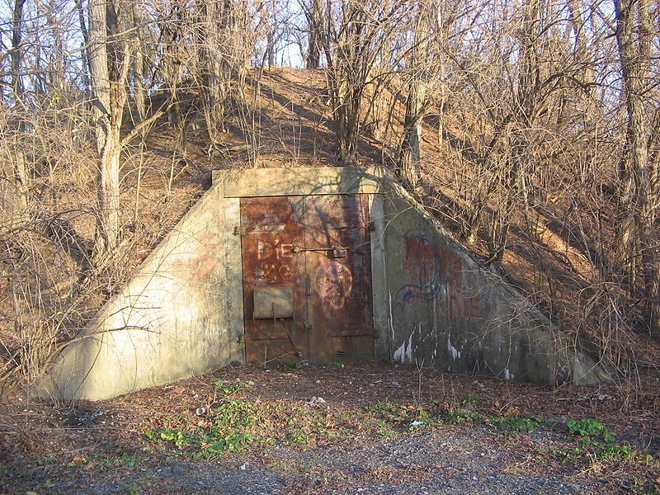

Figure 1: Main Visual Reference [8]

Fallout 4: Power Loss

Version 1.1

|  |  |
| --- | --- |
| Designer: | Blake Philley |
| Document Date: | May 29th, 2018 |
| Intended Level Delivery Date: | July 16th, 2018 |

**Document Revisions Table**

|  |  |  |  |
| --- | --- | --- | --- |
| **Version** | **Description** | **Requestor** | **Date** |
| 1.0 | Initial Document | Professor | May 29th |
| 1.1 | Added external cell location, colons added to table of figures for consistency. Clarified objectives – Get power coil is main, kill raiders is optional | Writer | June 4th |
| 1.2 | Power Coil Location added to 1F map and legend | Writer | June 11th |
| 1.3 | Added in two more raiders at the back of the bunker | Writer | June 29th |
| 1.4 | Edited maps to better reflect new areas. Added new terminal dialogue | Writer | August 28th |

# Table of Contents

Table of Contents 3

Table of Figures 4

Level Information 5

Quick Summary 5

Level Maps 5

Map Legend 6

Desmond’s Garage 7

Bunker Exterior 8

Bunker Interior 9

Objective(s) 15

Hook(s)/Gameplay Highlights 15

New Gameplay Mechanics 15

Campaign 15

Context 15

Backstory 15

Aftermath 16

Development Schedule 16

Key Theme References 17

Old and Shitty 17

Requirements 18

Feature List 18

Appendix A: Quest Summary 19

Main Quest 19

Desmond’s Dialogue 19

Diary Entries 21

22

Wish List 22

References 23

# Table of Figures

Figure 1: Main Visual Reference [8] 1

Figure 2: Map Legend 6

Figure 3: Desmond’s Garage Map 7

Figure 4: Bunker Exterior Map 8

Figure 5: Bunker Exterior Location, taken in game 9

Figure 6: Floor 2F 10

Figure 7: Floor 1F 11

Figure 8: Floor B1 12

Figure 9: Floor B2 13

Figure 10: Contact Sheet for the bunker interior and exterior 18

Level Design Document

# Level Information

## Quick Summary

Power Loss is a quest designed for Fallout 4. Players meet a mechanic in Diamond City named Desmond and are tasked with eliminating the raider group that has moved into an old pre-war military bunker used for testing weapons and power armor. Desmond needs a specific type of power coil from this base and the raiders are preventing him from reaching them. The X-19 power coil, as far as Desmond is aware, can’t be found anywhere else.

## Level Maps

All rooms on the maps have been labeled for convenience and will be referred to as such throughout this document if necessary.

The event grid shows only one possible path for the player to take. Other paths may end up being shorter or longer than shown here.

### Map Legend

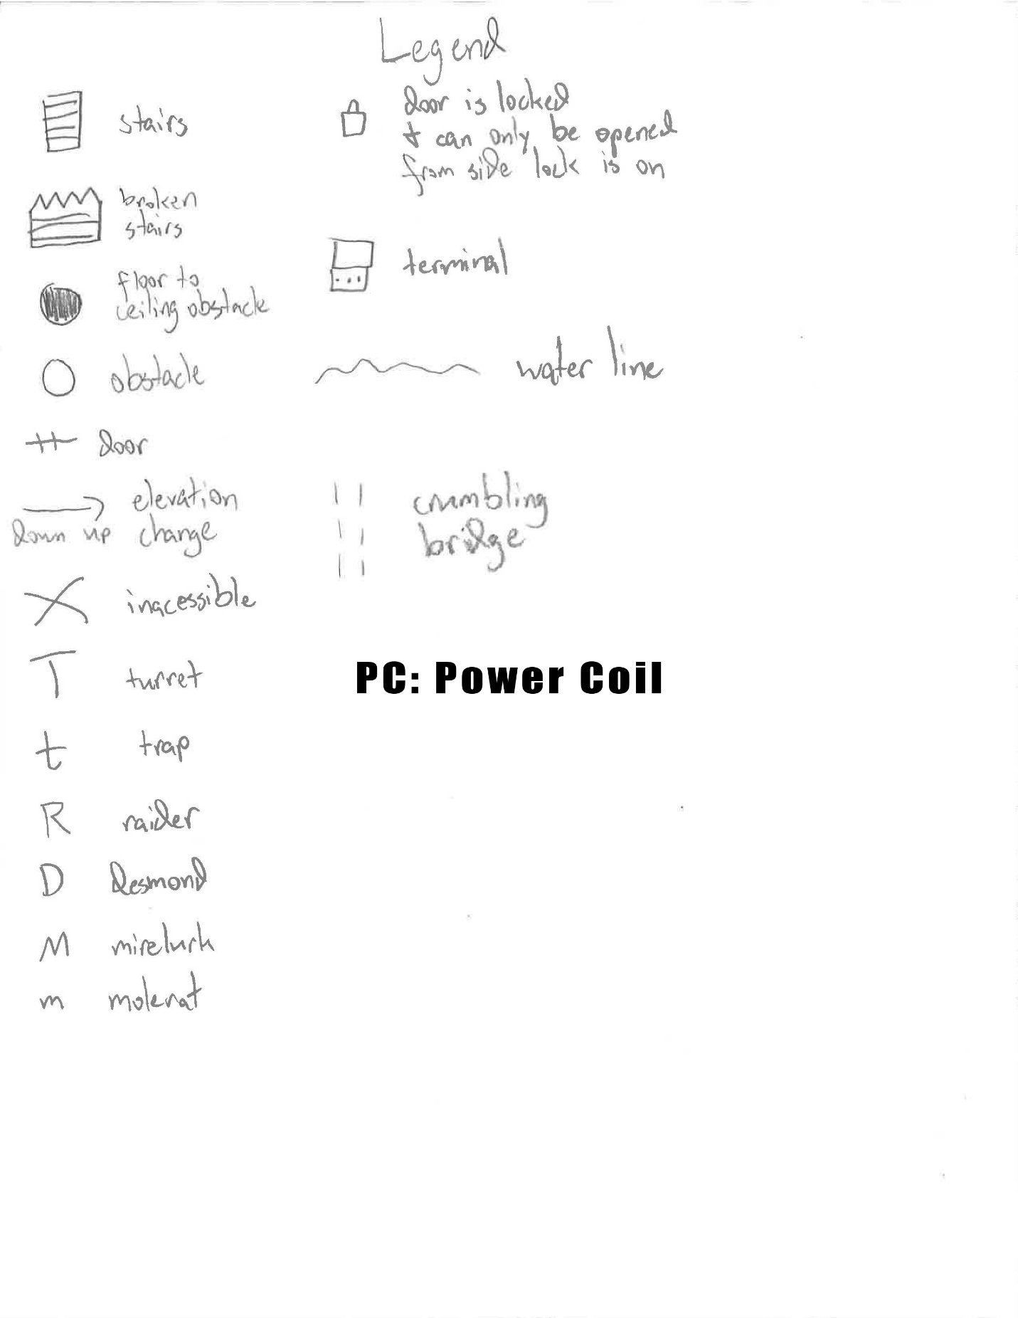

Figure 2: Map Legend

### Desmond’s Garage

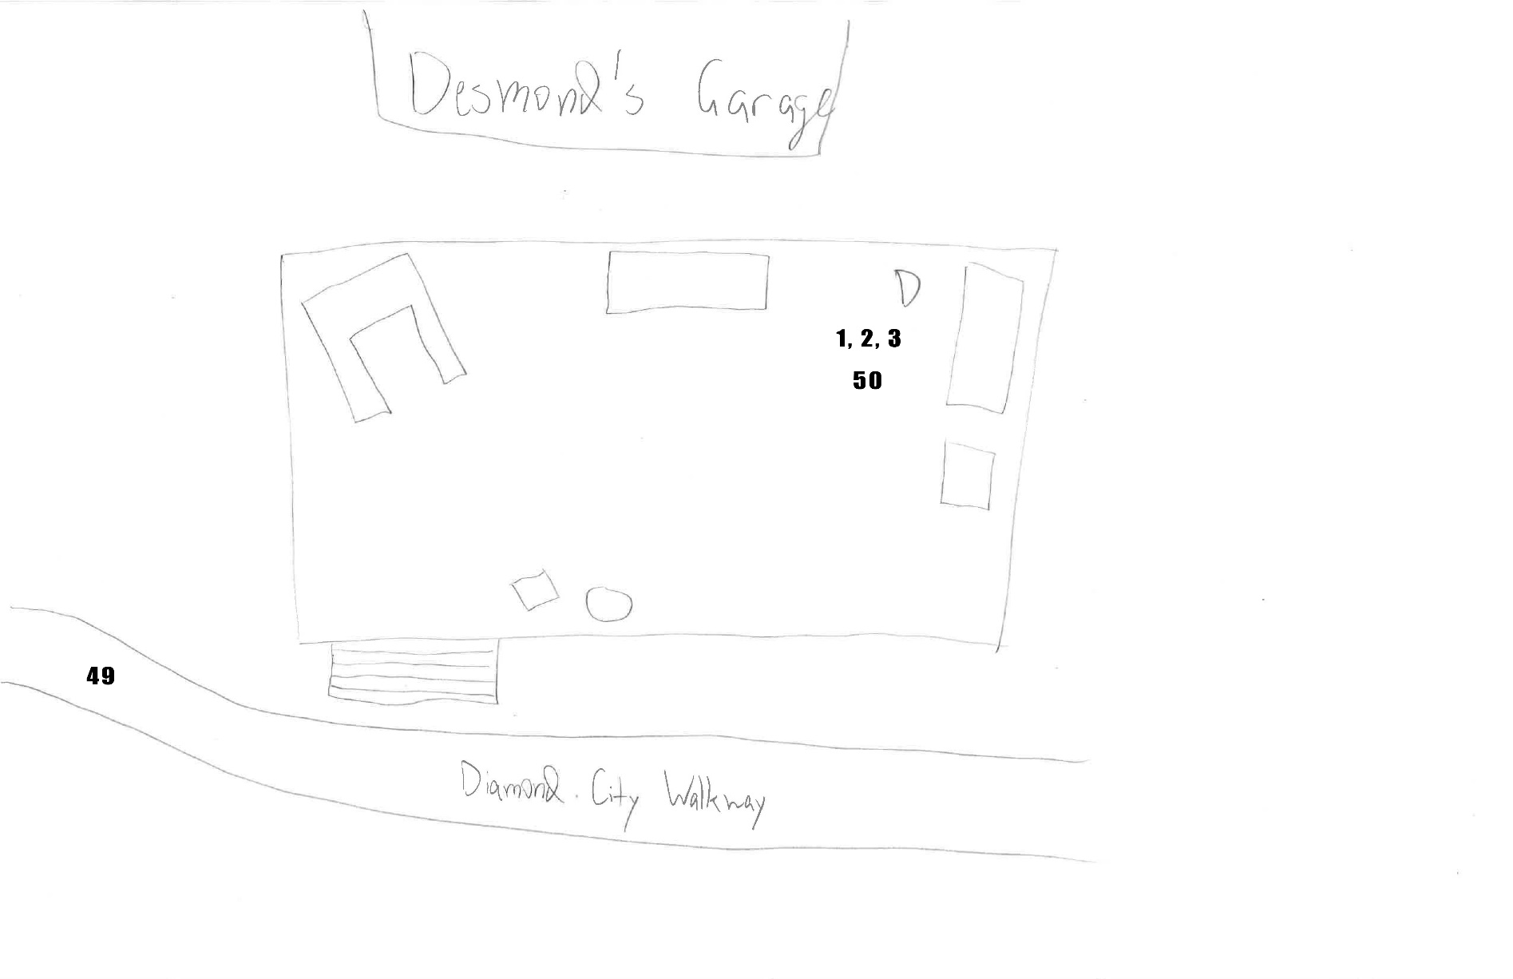

Figure 3: Desmond’s Garage Map

|  |  |  |  |  |  |
| --- | --- | --- | --- | --- | --- |
| Map Label | Event Description | Detail Information | Approx. Difficulty (1-10) | Approx. Time | Wow? |
| 1 | The player talks to Desmond |  | 1 | 0:00 | n |
| 2 | Desmond explains the situation and requests that the player clears out the raiders | Desmond explains to the player that he needs the raiders removed | 1 | 0:15 | n |
| 3 | The player leaves and heads to the bunker |  | 1 | 0:30 | n |

### Bunker Exterior

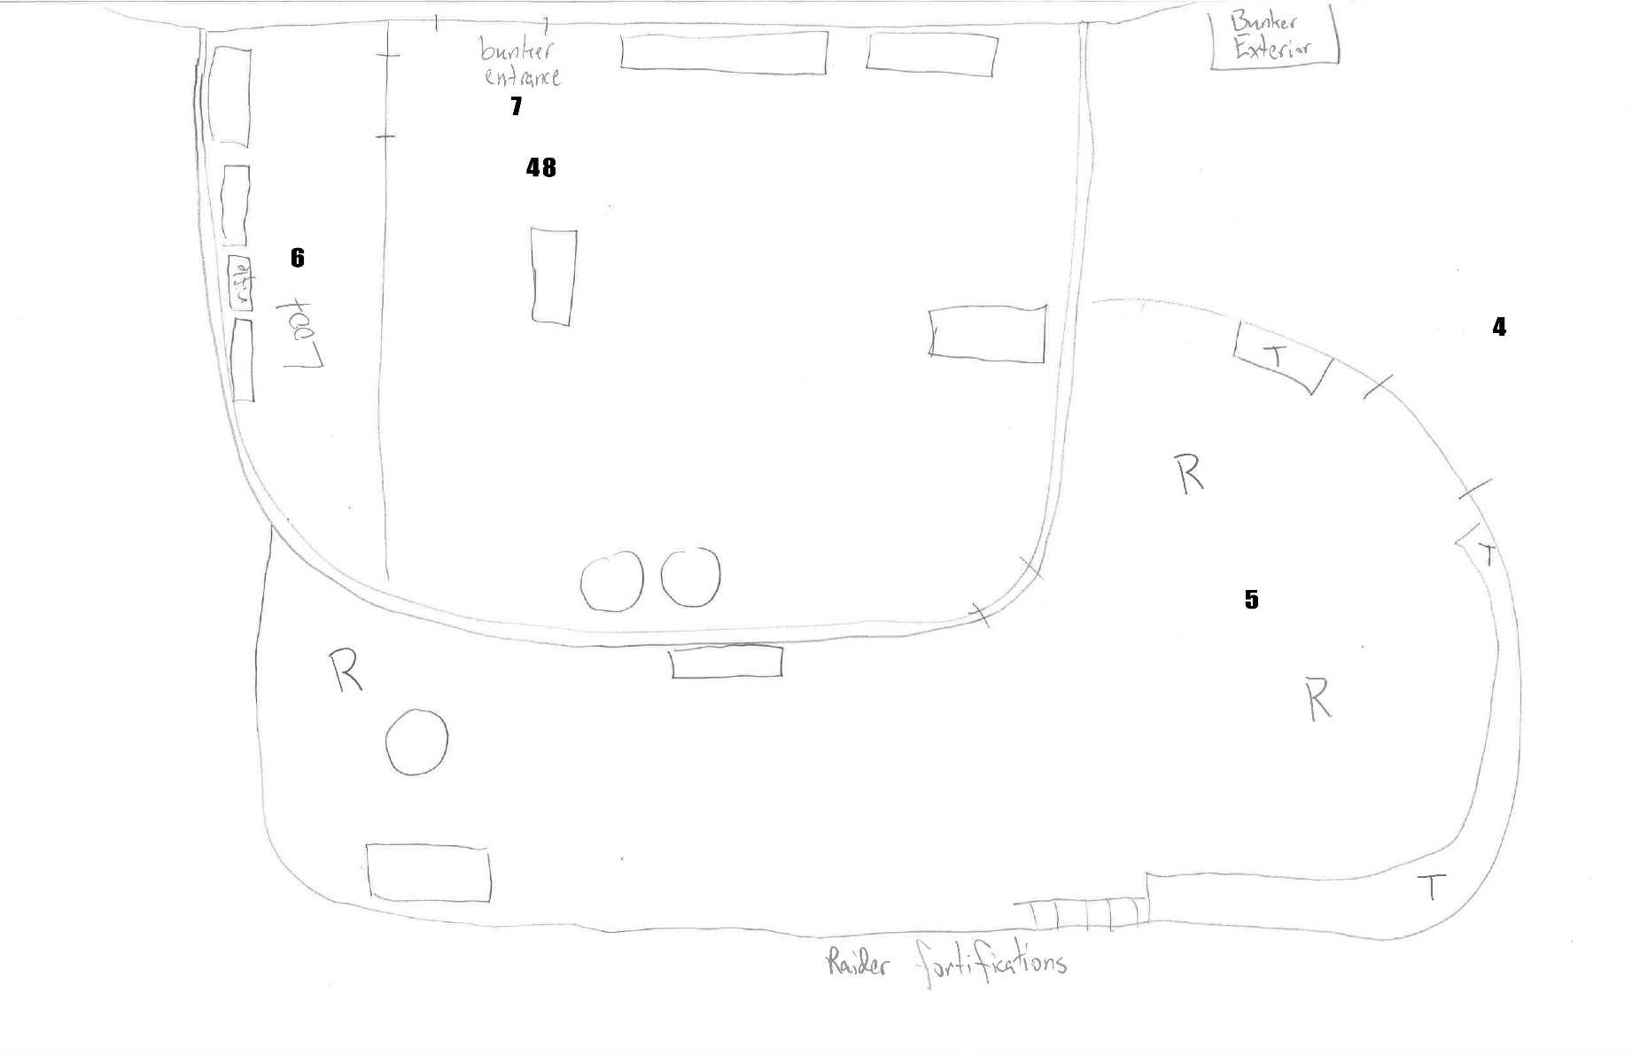

Figure 4: Bunker Exterior Map

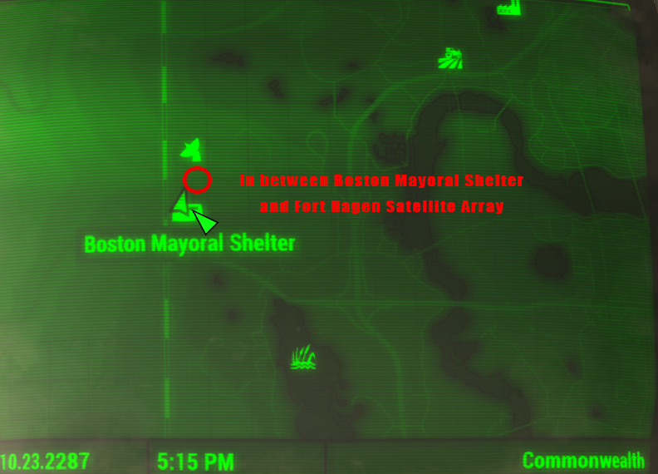

Figure 5: Bunker Exterior Location, taken in game

|  |  |  |  |  |  |
| --- | --- | --- | --- | --- | --- |
| Map Label | Event Description | Detail Information | Approx. Difficulty (1-10) | Approx. Time | Wow? |
| 4 | Player is attacked by turrets while entering the outer wall |  | 4 | 3:30 | n |
| 5 | Player is attacked by raiders on the inner area |  | 3 | 4:00 | n |
| 6 | (OPTIONAL) Player acquires loot |  | 1 | 4:30 | n |
| 7 | Player enters the bunker interior |  | 1 | 5:00 | n |

### Bunker Interior

Figure 6: Floor 2F

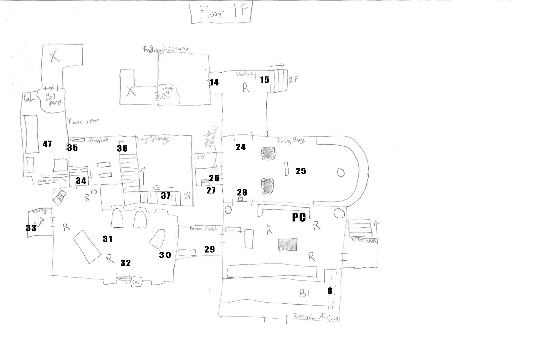

Figure 7: Floor 1F

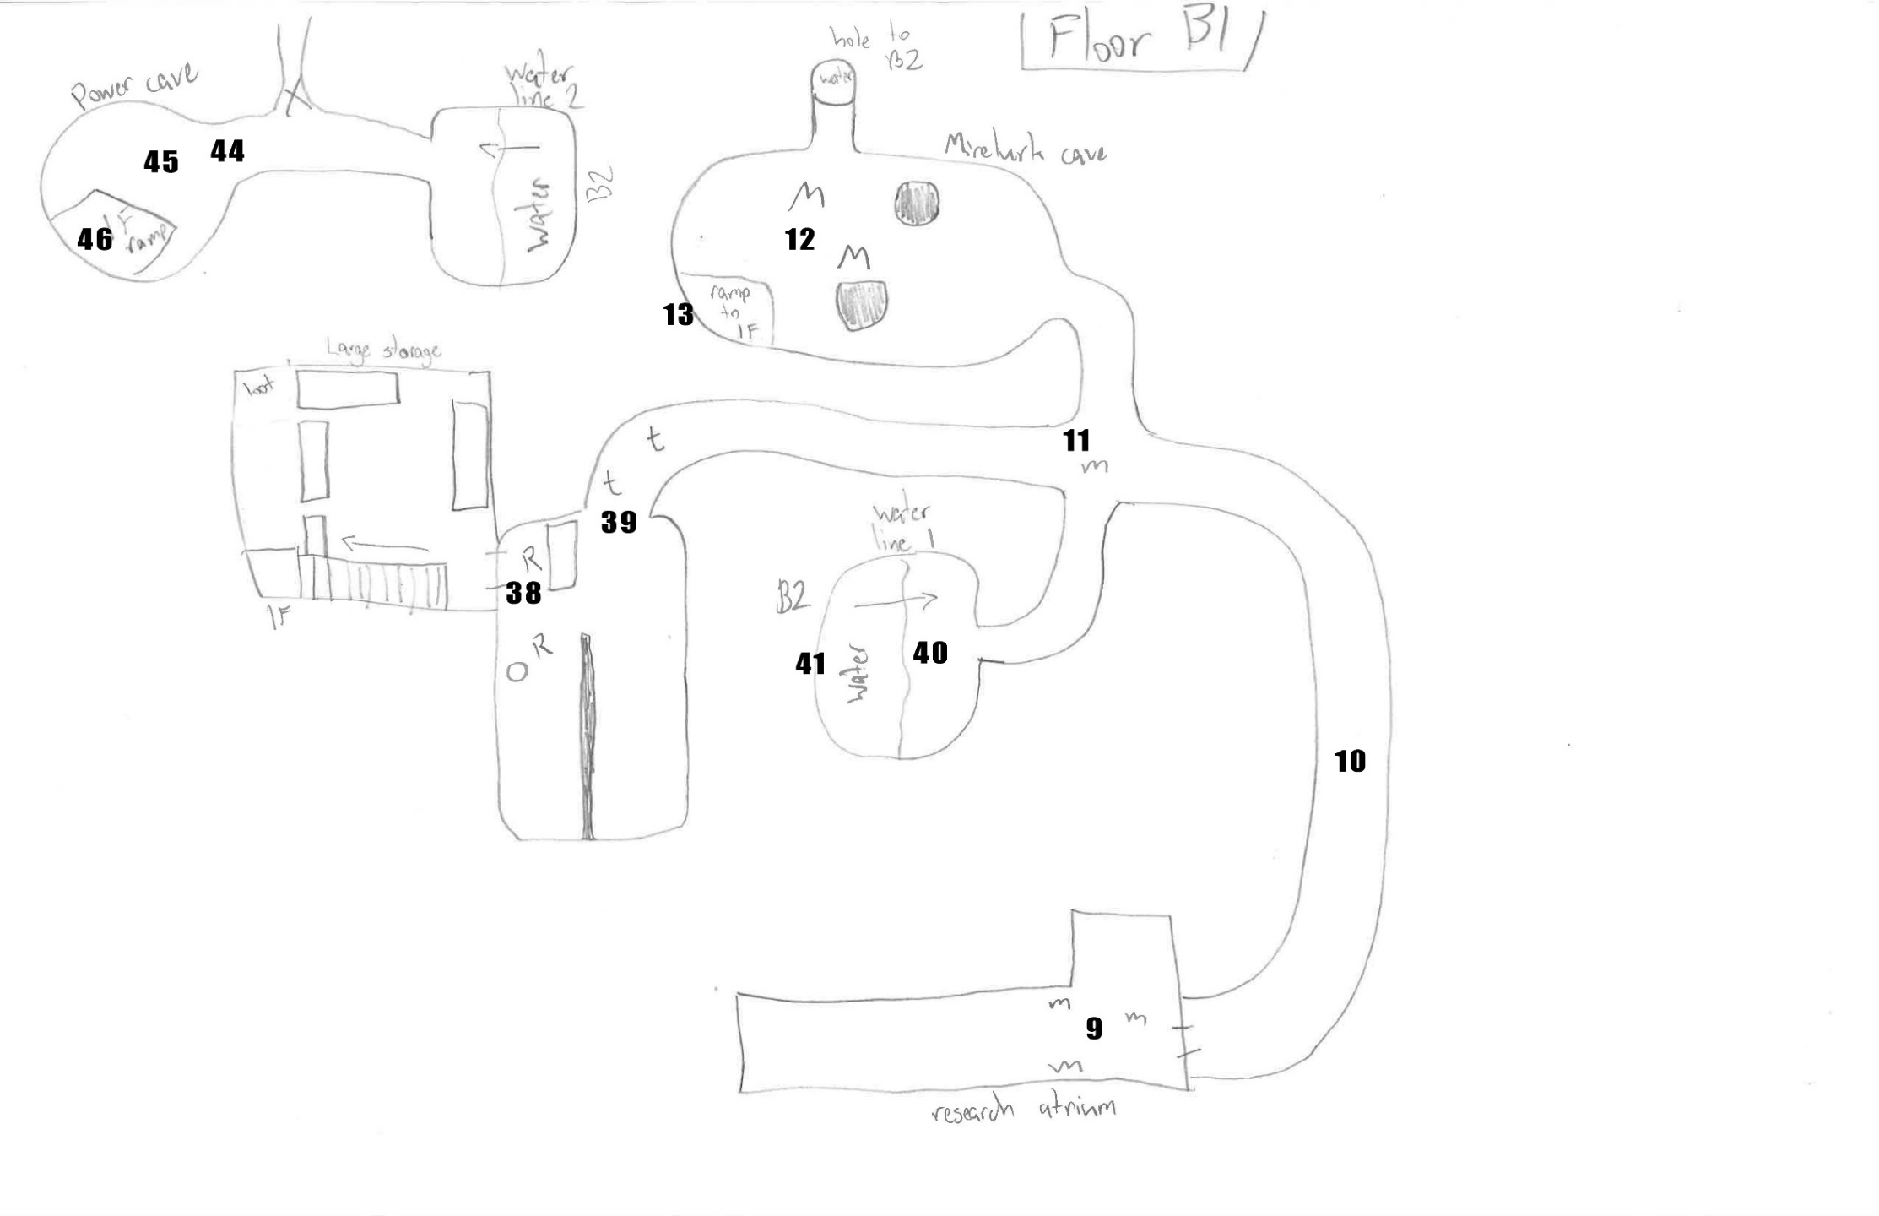

Figure 8: Floor B1

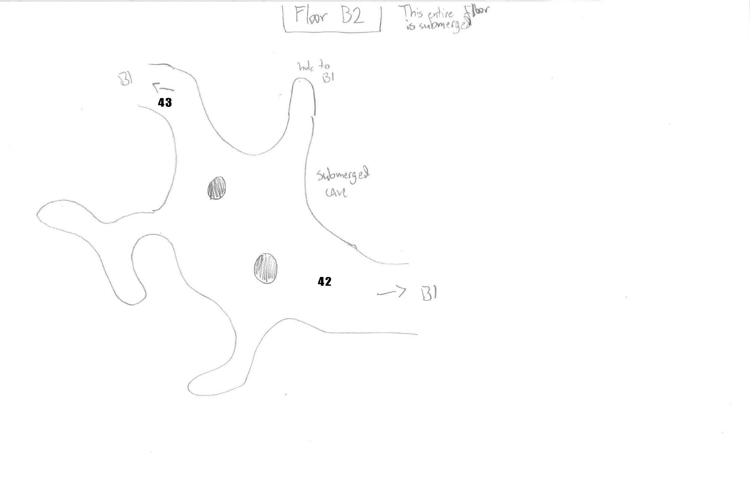

Figure 9: Floor B2

|  |  |  |  |  |  |
| --- | --- | --- | --- | --- | --- |
| Map Label | Event Description | Detail Information | Approx. Difficulty (1-10) | Approx. Time | Wow? |
| 8 | Player walks over the crumbling bridge | The bridge breaks and the player falls down  This should be somewhat surprising to the player.  Swap to B1 Map | 1 | 5:30 | y |
| 9 | Player is attacked by molerats | The molerats ambush the player. Players must think fast and react quickly | 5 | 5:35 | n |
| 10 | The player proceeds through the cavern interior | A suspenseful moment for the player in a small, dark cavern | 2 | 6:00 | n |
| 11 | The player can choose 1 of 3 directions here | The player is also attacked by one molerat here.  The play experience splits into multiple possible paths here. The following steps follow only one possible path. | 3 | 6:30 | n |
| 12 | 2 mirelurks defend their nest and a mini nuke | The mirelurk den is irradiated | 6 | 6:45 | n |
| 13 | The player proceeds up the ramp | The radioactive storage room is irradiated  Swap to 1F Map | 2 | 8:00 | n |
| 14 | The player proceeds into the hallway |  | 1 | 8: 30 | n |
| 15 | The player proceeds up the stairs to floor 2 | Swap to 2F Map | 1 | 8:45 | n |
| 16 | The player explores the break room area |  | 2 | 9:00 | n |
| 17 | The player proceeds into the bunk room | The player is attacked by 2 raiders in here | 3 | 9:45 | n |
| 18 | The two raiders attack the player |  | 4 | 10:00 | n |
| 19 | The player proceeds into the hallway |  | 1 | 10:30 | n |
| 20 | The player explores the locker room and bathroom |  | 1 | 10:45 | n |
| 21 | The player enters the main research atrium | Multiple enemies are present in this room. The player is in a position that is not easily defended. Enemies are present on 1F and 2F. Both maps have the enemies labeled for their respective elevation levels. | 1 | 11:15 | n |
| 22 | The enemies in the atrium attack the player | The player has little cover and must play more defensively in this situation. The raider boss and power armor raider are present here.  This fight is intended to be difficult. It is intended to be the ‘boss fight’ of this mod.  This is a tense and difficult fight. | 7 | 11:20 | y |
| 23 | The player enters the CO’s office and gets the power coil | Swap to 1F Map  The CO’s office is much more decorated than other rooms and has an interesting map on the wall. | 1 | 12:30 | y |
| 24 | Player backtracks into the firing range | The firing range has a much higher ceiling than most of the bunker and feels very open. | 2 | 12:45 | y |
| 25 | The player inspects the firing range |  | 1 | 13:00 | n |
| 26 | The player enters the X-01 storage room | Players will be very excited to see a suit of X-01 power armor. | 1 | 13:30 | y |
| 27 | The player inspects the room and learns about the locked door but cannot open it | Since this quest is intended for players around level 10 – 15, it is very unlikely that they will have master level hacking. | 1 | 13:35 | n |
| 28 | The player unblocks the firing range door |  | 1 | 13:45 | n |
| 29 | The player proceeds into the broom closet | In this path, the raiders are presumed to already be dead | 1 | 14:00 | n |
| 30 | The player enters the garage |  | 1 | 14:10 | n |
| 31 | Raiders attack the player in the garage |  | 4 | 14:30 | n |
| 32 | The player explores the garage |  | 1 | 15:00 | n |
| 33 | The player loots the storage room |  | 1 | 15:10 | n |
| 34 | The player enters the mess hall |  | 1 | 15:30 | n |
| 35 | The player sees the gatling laser and fusion core through a broken doorway | This is a clue to the player that they must navigate to here some other way. The players eye will be drawn here with flashing lights.  Players will want the Gatling laser and fusion core badly. Both are very rare and valuable. | 2 | 15:40 | y |
| 36 | The player heads into the large storage room |  | 1 | 16:00 | n |
| 37 | The player heads down the stairs and into the cave system | Swap to B1 Map | 1 | 16:10 | n |
| 38 | Raiders attack the player at the cave system | Once these raiders are dead the quest completes as they are the last remaining raiders | 3 | 16:15 | n |
| 39 | The player encounters a few traps at the mouth of the cave system |  | 4 | 16:45 | n |
| 40 | The player enters water line 1 |  | 1 | 17:00 | n |
| 41 | The player swims underwater into B2 | The difficulty is higher than normal for this task because player’s may not even think about swimming underwater to get somewhere  Swap to B2 Map | 5 | 17:15 | n |
| 42 | The player enters the submerged cave | This is a cool moment for the player. Underwater swimming doesn’t happen much in Fallout 4. | 1 | 17:20 | y |
| 43 | The player leaves the submerged cave and enters water line 2 | Swap to B1 Map | 3 | 17:40 | n |
| 44 | The player enters power cave |  | 1 | 17:50 | n |
| 45 | Mirelurks attack the player |  | 7 | 18:00 | n |
| 46 | The player proceeds up the ramp and into the power room | Swap to 1F Map | 1 | 18:45 | n |
| 47 | The player acquires the gatling laser and fusion core |  | 1 | 19:00 | n |
| 48 | The player leaves the bunker | Swap to Bunker Exterior Map | 1 | 19:30 | n |
| 49 | The player fast travels to Diamond City | Swap to Desmond’s Garage Map | 1 | 20:00 | n |
| 50 | The player returns to Desmond and turns in the quest |  | 1 | 20:30 | n |

## Objective(s)

* Return to Desmond with the X-19 power coil
  + OPTIONAL: Eliminate all the raiders in the bunker

## Hook(s)/Gameplay Highlights

* X-01 Power armor and Gatling laser
  + Players can acquire a suit of X-01 power armor in this bunker
  + Players can acquire a Gatling laser in this bunker
* Decrepit Bridge
  + After entering the bunker players must cross a decrepit bridge to proceed. This bridge crumbles underneath them and the player must navigate through a cave system to re-enter the bunker

## New Gameplay Mechanics

No new gameplay mechanics are being created.

## Campaign

This quest does not affect the overall Fallout 4 campaign.

### Context

There is no greater context to the player’s experience in this quest than what was explained earlier in the document. (Pre-War and pre-quest related information can be found in Diary Entries).

### Backstory

There is no more backstory information about Desmond or the raiders provided by this quest as it is superfluous for this experience.

### Aftermath

The raiders are dead, and Desmond can again scavenge at the bunker. Players are free to come and go as they please from the bunker.

## Development Schedule

|  |  |
| --- | --- |
| Milestone | Date |
| LDD | 5/30 |
| Initial Gameplay | 6/11 |
| First Gameplay Iteration | 6/18 |
| Gameplay | 6/25 |
| Per-room theme definitions constructed | 7/2 |
| Aesthetics | 7/9 |
| RTM | 7/16 |

## Key Theme References

### Old and Shitty

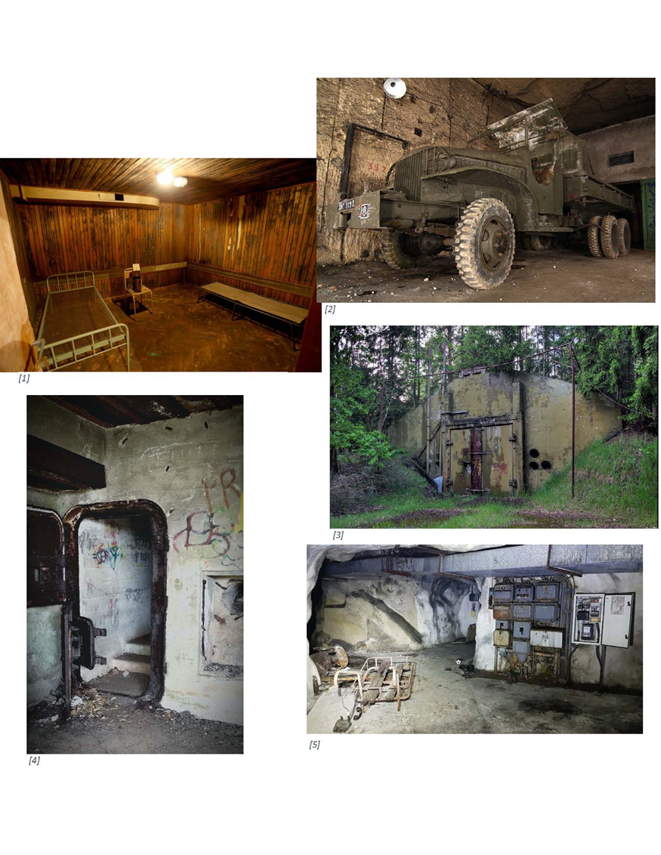

Figure 10: Contact Sheet for the bunker interior and exterior

## Requirements

The quest cannot exist without these features or would be so different without them that they are necessary.

|  |  |  |  |  |  |  |
| --- | --- | --- | --- | --- | --- | --- |
| Map Label | Description | Type | Goal | Priority | Expected Difficulty | Expected Time |
|  | Crumbling bridge | Trap | A different way to start the experience for players than most fallout content, adds mystery and pushes the player more towards exploration | Highest | Copy and paste | Minutes |
|  | Desmond | NPC | The NPC providing the quest. Someone has to give it to you. | Highest | Quest scripting – possible issues | Hours |

## Feature List

This is a list of features that I am planning for the quest that add to the experience.

|  |  |  |  |  |  |  |
| --- | --- | --- | --- | --- | --- | --- |
| Map Label | Description | Type | Goal | Priority | Expected Difficulty | Expected Time |
|  | X-01 Power armor | Item | Players can acquire a suit of rare X-01 power armor. It is locked behind a Master Grade terminal. Plays into the power armor testing facility lore. | Highest | Minimal scripting – terminal locked door | Hour |
|  | Gatling Laser | Item | A rare weapon. It is locked behind a Master Grade terminal. Plays into the weapons testing facility lore. | High | Drag and drop | Minutes |
|  | Diary Terminals | Lore | Terminals are placed around the facility which contain diary entries from people who worked at the facility before the bombs fell. | High | Minimal Scripting and Writing | Hour |
|  | Power Armor Raiders | Enemy | Plays into the power armor testing facility feeling. Can be used to ramp up difficulty over the course of the experience. | High | Drag and drop | Minutes |
|  | Reinforced Bunker Exterior | Area | Raiders have reinforced the bunker exterior and begun to dig into the position to defend it. | High | Unknown – not attempted previously | Hours |
|  | X-19 Power Coil | Quest Item | Required to turn in the quest | Highest | Low Scripting – performed before | Hours |

# Appendix A: Quest Summary

## Main Quest

### Desmond’s Dialogue

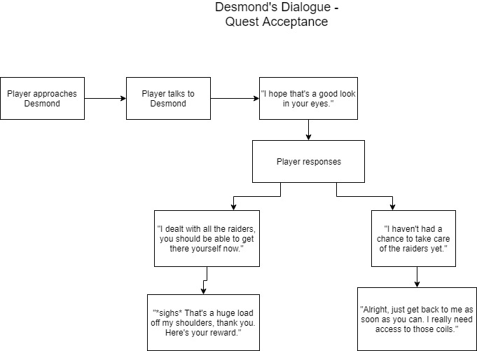

## Diary Entries

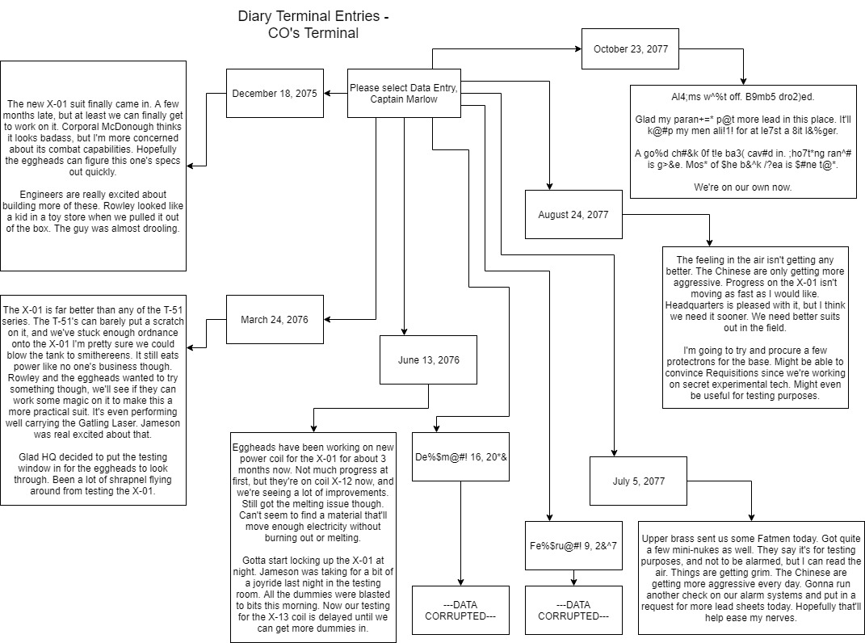Terminals are present in the bunker which provide the player with information relating to what happened here before the war, and some things the raiders have done with the bunker. That information is outlined here.

# 

# 

# Wish List

These features could be added if time allows:

**More Terminals with more lore –**

* Why -
  + Gives the player more information to read about what happened here in the past
  + Lore is cool
* Time Requirement -
  + Small - Medium

**More bunker area to explore –**

* Why –
  + Exploring is fun
  + People like finding secrets and sweet loot
* Time Requirement –
  + Large

**Expand Submerged Cave**

* Why –
  + Exploring is fun
  + Exploring in a way Fallout doesn’t always do adds variety for players and can make the experience memorable
  + Requiring players to think about their oxygen could make the experience more memorable
* Time Requirement –
  + Large

**Charisma Check with Desmond**

* Why –
  + Small bit of role-playing in the mod
  + Gives players value for characters that aren’t focused on only exploration and combat
* Time Requirement –
  + Medium

**Unique power armor suit (a suit that doesn’t exist currently in the game)**

* Why –
  + That’d be cool
  + Plays into the idea of a power armor testing facility
* Time Requirement –
  + Extreme

# References

[1] <http://www.recorder.com/Albania-Old-Bunker-1868155>

[2] <http://www.dailymail.co.uk/news/article-2138544/Inside-Frances-secret-World-War-I-bunker-Urban-explorers-wartime-weapons-stowed-away-underground-quarry.html>

[3] <http://www.thelivingmoon.com/45jack_files/03files/Russian_Atomic_Bunker_Old.html>

[4] <https://www.eyeem.com/p/58930214>

[5] <https://www.google.com/imgres?imgurl=https%3A%2F%2Fi.ytimg.com%2Fvi%2FIS75JddZSMg%2Fmaxresdefault.jpg&imgrefurl=https%3A%2F%2Fwww.youtube.com%2Fwatch%3Fv%3DIS75JddZSMg&docid=7_pJ95DN4MPXAM&tbnid=YZpFqJdQkIEi4M%3A&vet=10ahUKEwjrpO-KipraAhVHylMKHchGBhIQMwjuASgIMAg..i&w=1280&h=720&bih=593&biw=1284&q=old%20bunker&ved=0ahUKEwjrpO-KipraAhVHylMKHchGBhIQMwjuASgIMAg&iact=mrc&uact=8>

[6] <https://www.shutterstock.com/image-photo/old-generator-abandoned-military-bunker-605764649>

[7] <https://www.google.com/imgres?imgurl=https%3A%2F%2Fi.ytimg.com%2Fvi%2Fb2wRiwAgtfk%2Fmaxresdefault.jpg&imgrefurl=https%3A%2F%2Fwww.youtube.com%2Fwatch%3Fv%3Db2wRiwAgtfk&docid=9UKyyoGjhexCxM&tbnid=6Q4YIchSCgsydM%3A&vet=10ahUKEwjrpO-KipraAhVHylMKHchGBhIQMwi5AihIMEg..i&w=1280&h=720&bih=593&biw=1284&q=old%20bunker&ved=0ahUKEwjrpO-KipraAhVHylMKHchGBhIQMwi5AihIMEg&iact=mrc&uact=8>

[8] <http://www.onlyinyourstate.com/pennsylvania/pa-doomsday/>