UNWelcome - Tutorial 1

# Legend

This is an empty tile. Players can summon demons on this and neighbors can path over it and be moved over it by any demon.

This is the neighbors main path. Neighbors will move along this path until they are moved off of it by a demon.

This is the neighbor's starting tile. Neighbors spawn from here and move along the main path after spawning.

This is an exit tile. Neighbors will be removed if they touch this tile.

This is the Witch's tile. The neighbors are trying to reach this tile by proceeding along the main path.

These are obstacle tiles. Neighbors cannot be moved through these tiles or path through these tiles. Only a spring demon can move neighbors over these tiles.

The blue space is space being used for the background art.

# Level Layout

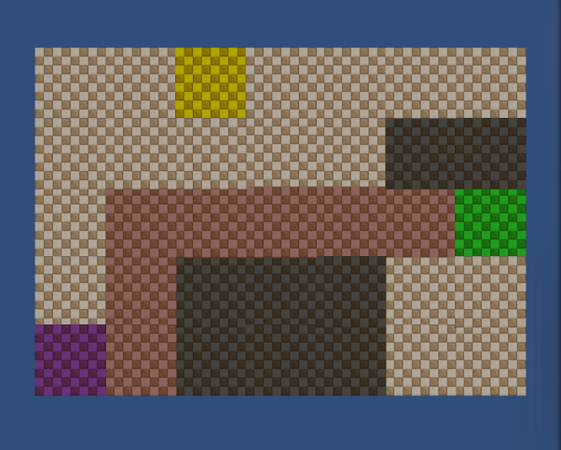

# Tutorial 1 Final Art

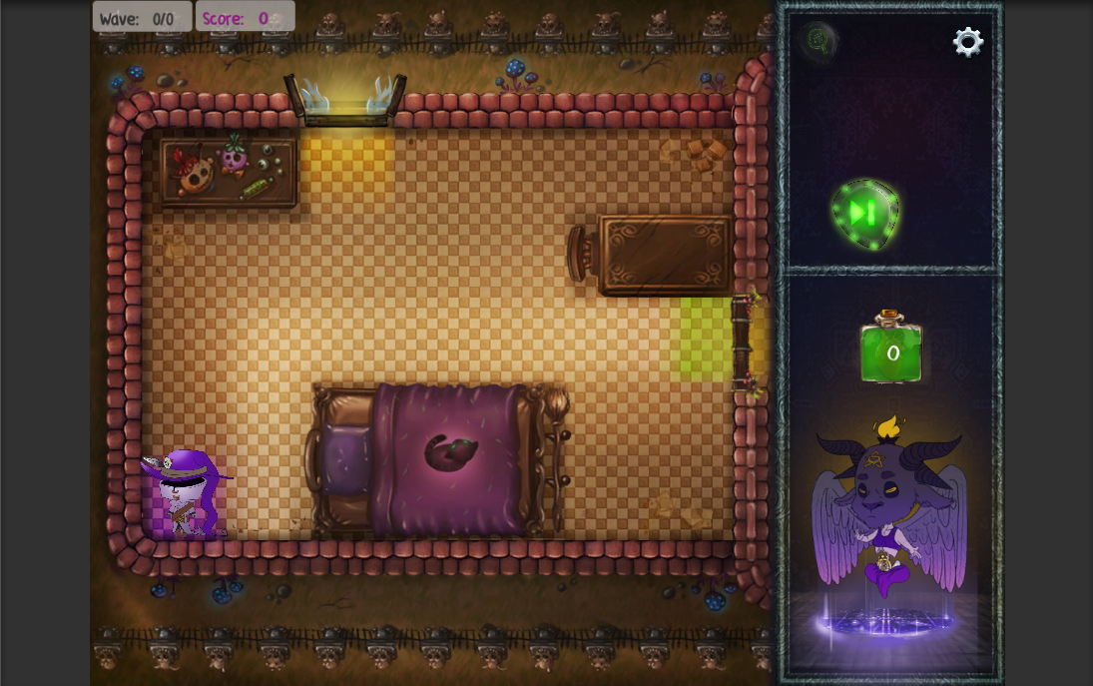

# Tutorial 1 Flow

Tutorial 1 is a hand-held experience. Players are walked through all the necessary steps to learn the following skills:

* Neighbor Movement
* Turn Functionality
* Demon Summoning
* Push Demon Mechanic
* Spending Energy and Gaining Energy
* Waves

These are the most basic pieces of information a player needs to know to be able to play UNWelcome.

These are the steps players go through in this tutorial:

1. The tutorial begins and a neighbor appears
2. Players are told to remove the neighbor
   1. In this step players are taught how to summon demons and what an exit looks like
3. Players summon a push demon
4. Players tap next turn and watch the neighbor be removed through the window tile (exit tile)

# Design Choices

This first tutorial is very small. Only two enemies total spawn and there is only one possible exit. This is to make it easier for players to learn the necessary information, because if the player does not learn the base skills, such as how to summon a demon or what the main path is, they won’t be able to play the game at all. Obstacles are present in this level but not introduced as a mechanic to reduce the cognitive load on the player’s memory.

In its earliest iteration this tutorial contained more information and skills to learn. However, testing within the team showed that too many skills to teach all at once would be difficult for players to remember, so I made another tutorial level to teach those other skills.

# Artistic Choices

I chose to go with a bedroom theme for this level because players would immediately understand this to be a much smaller space. Additionally, the bedroom theme allowed me to use less furniture and still seem like a realistic room.

A window was chosen for the exit in this tutorial because the window is the most frequent type of exit used and introducing the player to this exit early helped to cement it in the player’s mind as an exit.

The art assets were not created by me, but I explained what I would need to one of our artists and worked with him on the vision of the level.