SCI FI

EVERYTHING IS SUBJECT TO CHANGE

Table of Contents

Change Log 3

Overview 4

One Sentence Summary 4

High Concept 4

Gameplay overview 4

Pillars 4

Pillars Explained: 5

Target Audience 5

Core Audience 5

Ancillary Audiences 6

Loops 6

Style Guide 11

Racing Experience 18

Mechanics 18

Car stats and basics 18

Accelerating 19

Pickups 21

Modes of Play: 24

Tracks 26

Multi axis Tracks 26

Level 1 27

Level 2 28

Level 3 28

Level 4 28

Environments 29

Level 1 29

Level 4 30

User Interface: 31

Controls 36

Race Controls 36

Menu Controls 36

36

Characters 37

Technical 38

AI 38

Rubber Banding 38

AI Script 38

Backpack 38

Physics 38

Freefall 38

Colliding with barriers 39

Camera 41

# Change Log

|  |  |  |  |  |
| --- | --- | --- | --- | --- |
| Date | ATTENTION | Sections | Changes | Signature |
| 2/16 | TEAM | All | Init | Blake |
| 2/20 | Track/Cars | Boost | Players can boost on any lap | Blake |
| 2/20 | TEAM | All | Changing language of cart to vehicle or car | Blake |
| 2/22 | TEAM | Pillars, loops, High concept | Added high concept statement, added secondary and tertiary loops, added clarification for pillars | Blake |
| 2/22 | Code | Vehicles stats | Added integrity, clarified boost |  |
| 2/26 | TEAM | Change log | Added signature section | Blake |
| 2/26 | Physics | Drift | Clarified how drift will work, and what a successful drift is | Blake |
| 2/26 | BPAT, Physics, TEAM | Acquiring Pickups and Pickup spending, Brake, All sections | Clarified acquiring pickups.  Clarified what pickups do when spent.  Different vehicles have different brakes.  Changed integrity to energy  Added table of contents | Blake |
| 2/27 | TEAM | Pillars | Changed HYPE to Excitement, and Couch co-op to couch multiplayer. Added customization thru gameplay, and speed  Added target audiences | Blake |
| 3/6 | Physics | Drift, added camera section | Clarified drift, visuals in progress  Added camera section to physics | Blake |
| 3/20 | TEAM | Pillars, Racing Experience, Pickups, Mechanics | Changing design spec to new A/B design | Blake |
| 3/23 | TEAM | Track Features | Updating pads with new changes (added atom boost pad) | Blake |
| 4/11 | TEAM | Pads, Drift | Atom boost is cut, Drift is cut | Blake |
| 4/19 | TEAM | Air Control, Hazards, Levels | Air Control is no longer a supported feature. Hazards and levels have been updated and clarified | Blake |
| 5/4 | TEAM | Loops. Expertise, Hazards, UI, AI, Rubber banding | Removed deprecated loops (pickups, unlocks) added new loop (gates). Hazards are cut. Expertise button only works on boost pads. Updated UI. AI behavior is updated. Rubber banding behavior added. | Blake |

# Overview

## One Sentence Summary

Interstellar Racing League is a high-speed racing game set in the distant future. Players race as larger than life personalities for fame, glory, and money across different worlds.

## High Concept

Interstellar Racing League is a high-speed couch multiplayer racing game set in the distant future. Players race in one of four unique, high octane cars. Players have the choice of racing in two different environments - a colossal city, and an ancient desert. In multiplayer mode 2 to 4 players can compete against one another and 4 to 6 AI-driven CPUs in single races or take on the grand prix, where they race across all four tracks. In single player mode players can choose to race against 7 AI opponents or take on time trials, where they will race against a predetermined time and attempt to beat it. The game features arcade-style physics and a set of visually rich environments brought to life by an art style inspired by classic science fiction films like *Star Wars* and *Blade Runner*.

## Gameplay overview

There is a total of 8 players in the race, including AI (the number of AI depends on the number of human players). Players begin the race at a Standing Start. Players race around the track until all the human players have crossed the finish line. Players can utilize special powerup pads to give them an advantage over their opponents. The players can use a boost pad to gain a large burst of temporary speed, a knock pad to cause other players to spin out, or a shield pad to partially phase out of existence and drive through other vehicles.

## Pillars

* Mech n Tech
* Excitement
* Couch Multiplayer
* Customization through gameplay
* Speed

## Pillars Explained:

**Mech n Tech -**

The far-flung future. Mechanical systems are still recognizable to people from 2018, but they run vastly improved software. A document explaining this concept in more depth is in perforce. (TGP2\SciFiRacer\Docs\GameDesign\Mech n Tech Explanation.docx)

**Excitement -**

We want players to be excited when playing our game. We want interaction between players and we want to get players to hoot and holler. We want them yelling and shouting and having a fun time among friends. We want to create exciting moments for the players, between the players.

**Couch multiplayer -**

The experience of racing against people and racing with friends is paramount. Players are always racing against someone, players are never racing alone. Racing alone is not the experience we are going for. Players should be interacting and playing with each other, not near each other.

**Customization through Gameplay -**

~~Players customize their vehicle in the middle of the race. Players will be improving their vehicle while racing and changing the stats on their vehicle as well as the way it looks. Parts will be attached and detached during the racing experience.~~

Players can acquire a type of upgrade that allows them to use it at a later time.

**Speed –**

The game experience is all about speed and adapting to situations. Players will be going fast basically at all times. If players don’t want to be going fast we’ve made a mistake.

## Target Audience

### Core Audience

**This audience is our main focus. We are trying to appeal to these people first before any ancillary audiences.**

#### Casual Racing Game players:

* They like arcade racing (games like hydro thunder or wipeout) but aren’t very interested in simulation racing games (games like Forza)
* They aren’t highly competitive. They like winning but not at the expense of enjoying the game
  + Their focus is enjoying the experience and having fun more so than winning. Winning is fun, but not the only goal for these players
* Wishes games like F-zero and wipeout were still being made in today’s market
* They like playing with friends

### Ancillary Audiences

These are other audiences we want to be able to enjoy our game. These audiences are not the focus for our experience, but we want to appeal to them in some way as well.

#### Hardcore Racing Game players:

* The kind of person who really pushes the bounds of a racing game
  + They know every track and the most efficient path of every track
  + The kind of person who can fly in F-zero
* Loves going fast
* Will analyze parts to find the most efficient vehicles and most efficient strategies
* Sometimes prefers to race alone

## Loops

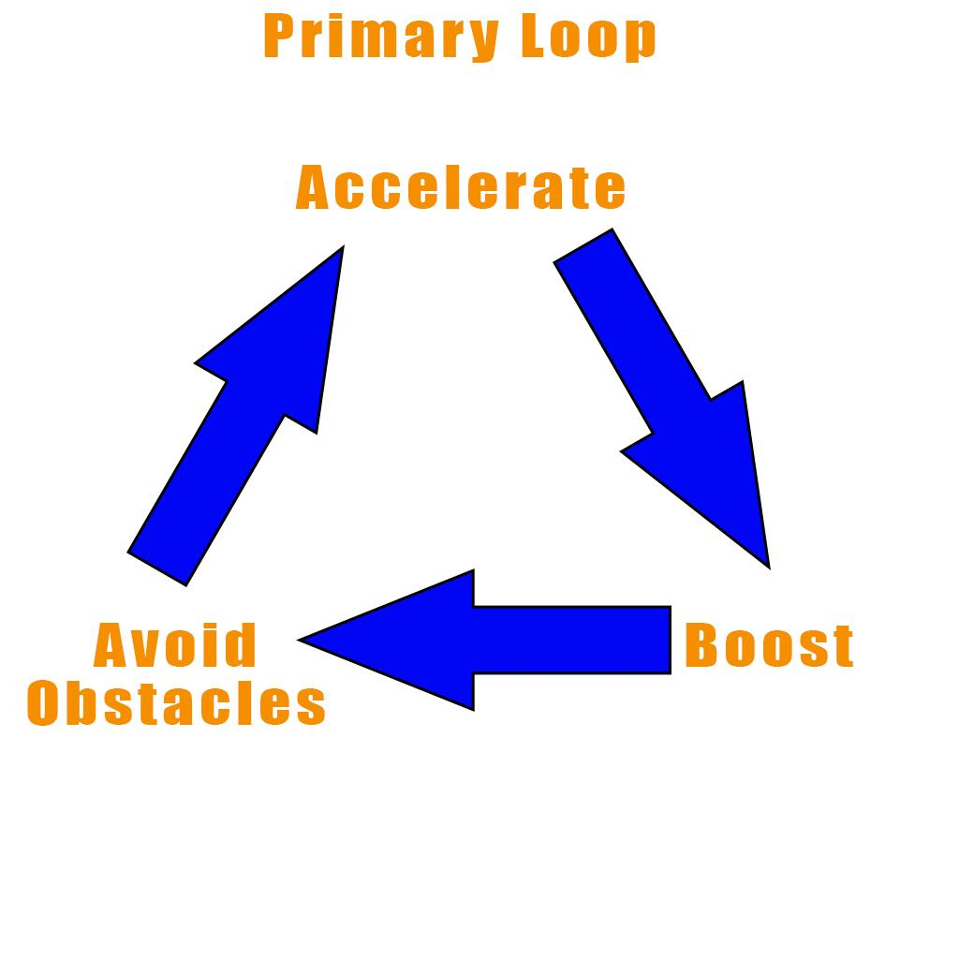  
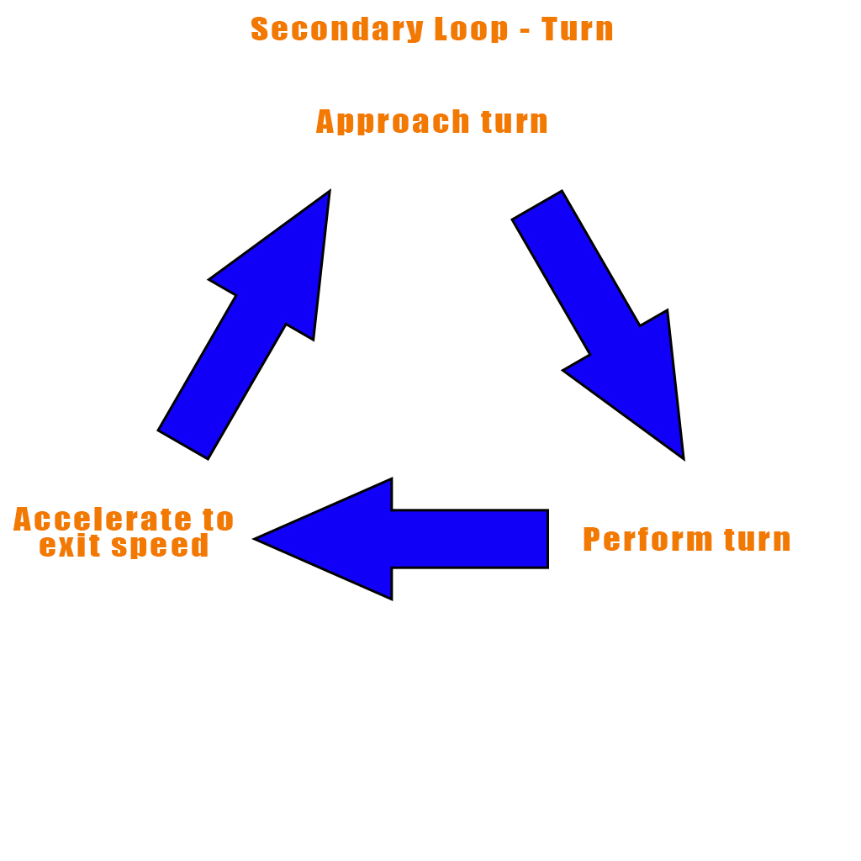

## 

## Style Guide

For Those Using this Manual.

The art style guide is a visual guide developed to maintain a consistency in visual style and art flow. It contains all the rules and guidelines that are recommended for this project. This would include Shape language, Color pallet, Lighting and tonal values and the overall Design Language.

Please note that the Art style guide is not a Rule book. On rare occasion, rules are meant to be broken. We recommend that you refer to this guide so that your work is in sync with other artist.

Like the GDD, the Art style guide is a living document, however it is not as long lived. Always consider it a WIP draft and please refer to it from time to time for updates in design notes.

We hope this document proves helpful in creating

An Awesome Game!

Early Kart Concepts

For starters we’ve factored in everyone’s Kart concepts. Allot of the designs that came from our amazing artist proved to be of great inspiration! This has helped us narrow down our decision and come to some consistency in style and lock on a visual language.

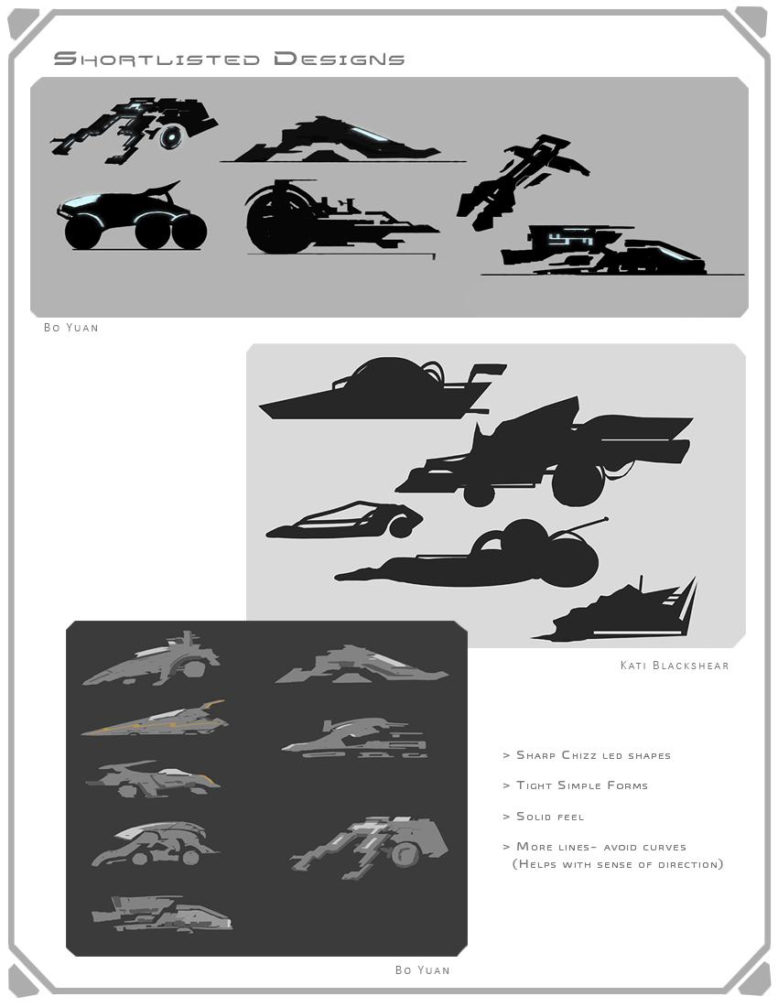

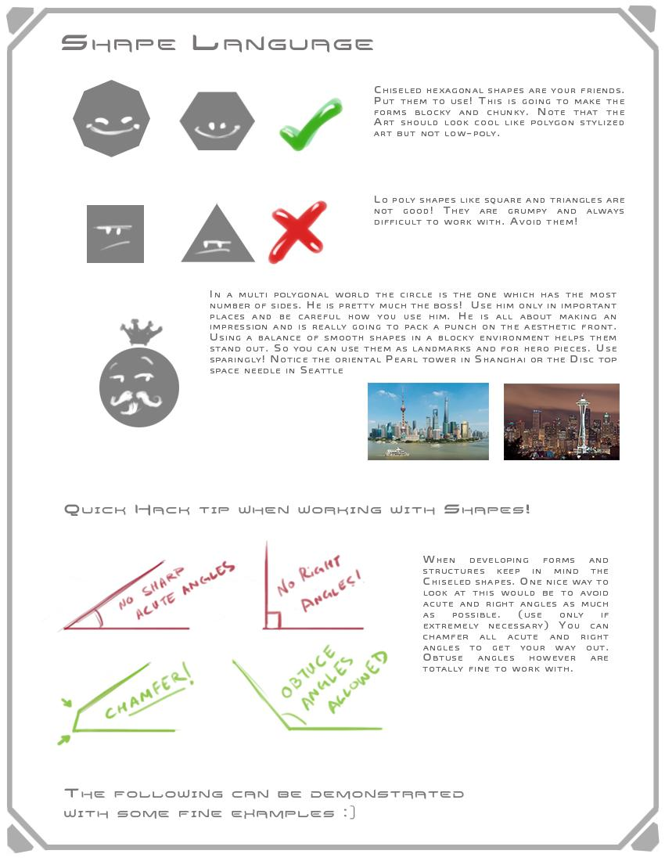

Shape language

The reason we decided to go with chiseled shapes is because we felt they fit well with a Sci-fi theme. Considering a Sci-fi futuristic kart racing game these shapes would very well define a techno, cyber feel. As mentioned earlier rules are meant to be broken. The objective here is to make sure the overall base silhouette in chunky and blocky, not too sharp and poly-dimensional. This treatment note will be followed throughout the Kart Designs and are also expected in the environments so that the two departments are conveniently able to integrate style.

Note: Any shape above the Pentagon works fine! However, the hexagonal and octagonal shapes have only been used as examples. Please don’t feel restricted to these shapes. Artist have all the design liberty as long as they chamfer and chisel as much as they can.

Another reason we felt these shapes would work best is because they are hard surface, provide a good sense of direction (which will prove helpful in conveyance) and are easy on the eyes- in a fast pace game.

Please note when altering shapes (Chevrons for instance) be sure to maintain consistency in form so that they are still recognizable to players and their identity is not lost. Do not over stylize.

Below is a basic visual distinction of how this sense style works:

The Happy Hexagon and the Sad Square

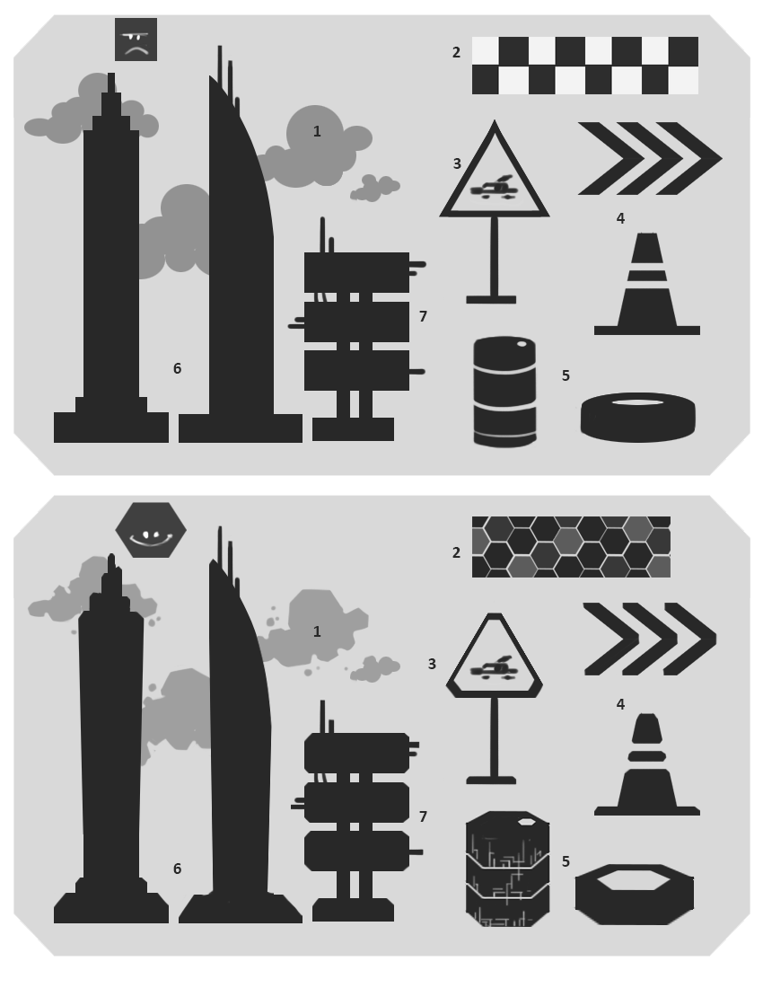

1. Remember how Circle was royalty. Well yes! That applies. Even to the clouds. Try to get the shapes as chunky as possible and yet make them look organic. We are working with Alien Planets after all.
2. The checkered marks which go on the flag tracks and the start and finish lines. Having cool lights on these would be awesome. Remember! Squares are no longer our friends because they are always sad ☹
3. All signages should have some distinct shape. It doesn’t have to be a chiseled triangle. It could be a chiseled square or a hexagon too. We like offsetting and making things look clunky and cute.
4. Note the Road cones and Chevrons. For the game we will have Sci-fi Futuristic derivatives of these! Be sure that whatever you design (Especially track props) is very easily conveyable and doesn’t lose its identity.
5. Thought You’d get away with Cylinders…?? HA! These too need to be clunky and chiseled. Adding cool enhancements is definitely encouraged! 😊
6. Note the Buildings. Apart from having chiseled edges, they are slightly warped and offset. If you can achieve this look in 3D that would be really cool!
7. Like we mentioned, Rules are meant to be broken! Look closely at the 3rd building… it has right angles at the pillars. You can get away with minor details. The objective is to get the overall shape to fit the style.

# Racing Experience

## Mechanics

### Car stats and basics

Vehicles are separated into two classes determined by their weight. Stats function on a spectrum.

Vehicle stats are:

|  |  |  |  |
| --- | --- | --- | --- |
| Top Speed | Handling | Acceleration | Weight |
| Top speed is a measure of the maximum speed of the vehicle without boosting. Measured in km/h. | Handling describes the vehicle’s ability to make a turn at various speeds. Higher handling means the vehicle can take sharper turns at higher speeds. | Acceleration is the rate at which the car increases its speed when the accelerate button is pressed. | Weight is an arbitrary number that is used as a way for us to communicate ‘control style’ to a player. (Explained below) |

These are the stats that are visible to players.

**Vehicle Weights:**

Like the other stats vehicle weight is a spectrum. This chart describes the general stats and controls for vehicles of different weight classes. (Each of the vehicles in the weight classes should have unique

|  |  |
| --- | --- |
| Lighter Vehicles | Heavier Vehicles |
| Lighter vehicles are characterized by being smaller and having superior acceleration and handling. Lighter vehicles also decelerate more quickly and having improved brakes.  Lighter vehicles are more dramatically affected when being bumped and Boost Knocked. | Heavier vehicles are characterized by being larger and having superior top speed and boost. Heavier vehicles decelerate less quickly and have weaker brakes.  Heavier vehicles are less dramatically affected when being bumped or Boost Knocked |

|  |  |
| --- | --- |
| Lighter Vehicles | Heavier Vehicles |
| +Acceleration  +Handling  +Deceleration  +Brakes  +Air Control (since the vehicle has better handling)  -Bump  -Boost Knock | +Top Speed  +Boost  +Bump  +Boost Knock  +Air speed  -Acceleration  -Handling |

### Accelerating

Players can accelerate at a fixed to give their car speed. This rate is set on a per car basis (each car has its own acceleration stat). When not accelerating all cars should decelerate at a fixed rate, relative to their weight.

Lighter cars decelerate faster, while heavier cars decelerate more slowly.

Braking

All cars can brake. This quickly decelerates the car instead of relying on simply lifting off the acceleration.

Each car has a different set of brakes. This means that different vehicles brake at different rates.

As a general rule again, lighter cars can brake more quickly, and heavier cars brake more slowly.

Air Control

No longer a supported feature. Cut due to scope and technical concerns. Players were leaving tracks and flying off into space too frequently.

Bumping

**Bump**

A bump is when the vehicle collides with another solid object. A bump has a minor effect physically and on the car’s energy.

**General collision**

When the player collides with a barrier or solid object they should bounce off it and preserve most of their momentum.

**Car collision**

When two cars collide, they will bounce into opposite directions. The heavier car will be bounced less than the light car.

Collision is detailed further in the Physics>Colliding.

### Expertise Button

This is a button that, when pressed at the right time, will cause a positive effect for the player to occur. This button can only be used on boost pads (See: Track Features for an explanation of the pad ~~and color mechanic~~). If pressed correctly, the player receives a greater boost.

Alternate Paths (Shortcuts)

Tracks have alternate paths. A player’s ability to access these alternate paths is determined by their skill as a racer. Shortcuts and alternate paths are generally characterized as being more difficult, but more rewarding (i.e, the player can get ahead of the pack by going through the shortcut).

Track Hazards

Hazards are cut due to scope concerns. We were unable to get our hazards to a shippable quality in time so they were cut. They caused too many issues on players that were too punishing.

Goals

The player’s ultimate goal is first place in the race.

# Modes of Play:

Tournament:

Tournament mode consists of a player racing through every track, winning a trophy based on their performance in all tracks. (Gold, Silver, Bronze, etc.) (Medals are not final in example).  
  
Players earn points based on their place in the race:

1st: 10

2nd: 8

3rd: 6

4th: 5

5th: 4

6th: 3

7th: 2

8th: 1

The player with the most points at the end of the tournament wins 1st overall, the player with the next most wins 2nd overall etc.

If players tie, the player with the fastest time overall wins the tie.

Time Trial:

Time Trial mode is designed to allow players to race against predetermined track times to improve their mastery of a track. Players will be given the “Champion’s” time on every track as a goal and will have their best displayed to additionally race against.

VS Race:

Vs Mode allows players to race against friends and CPUs alike on any track of their choosing with no actual stakes or goals other than pure racing. This mode’s goal overall is to allow players to play individual tracks at their leisure in any order they like.

# Tracks

### Multi axis Tracks

Tracks can be multi axis and be created free form in space. The vehicle stays on the track in all cases except for 1. (See: Freefall) The vehicle uses the track as its ground and stays magnetized onto it. The vehicle has a small degree of bounce when moving over the track, but this bounce is not enough to push the vehicle off the track.

### Track Features (Pads)

Every track has an available set of features. These features are present on all tracks and affect vehicles when the vehicle passes over them. **The effect is activated when the player passes over the pad.**

|  |  |  |
| --- | --- | --- |
| Boost Pad (Neutral) | Knock Pad (Colored) | Shield Pad (Colored) |
| Gives the player a speed boost when they pass over it. | If the player bumps another player during the time they have this modifier, the other player is sent away more than a normal bump. | Gives players a protective shield. This shield will allow players to drive through other vehicles. (The player’s collision is disabled while this is active.) |

**Conveyance**

* How does the track help tell the player which way to go?
* How does the player know where they are on the track in relation to the starting line? (Exclude features like a mini map. The track should speak for itself in this regard)
* How does the track work with the environment to set a mood for the level?
* How does the player know what’s coming? (i.e. how are sharp turns indicated)
* How does the player know where they are in the world? (This is important for getting a player to understand a multi axis track and how that relates to their understanding of where “down” is.)

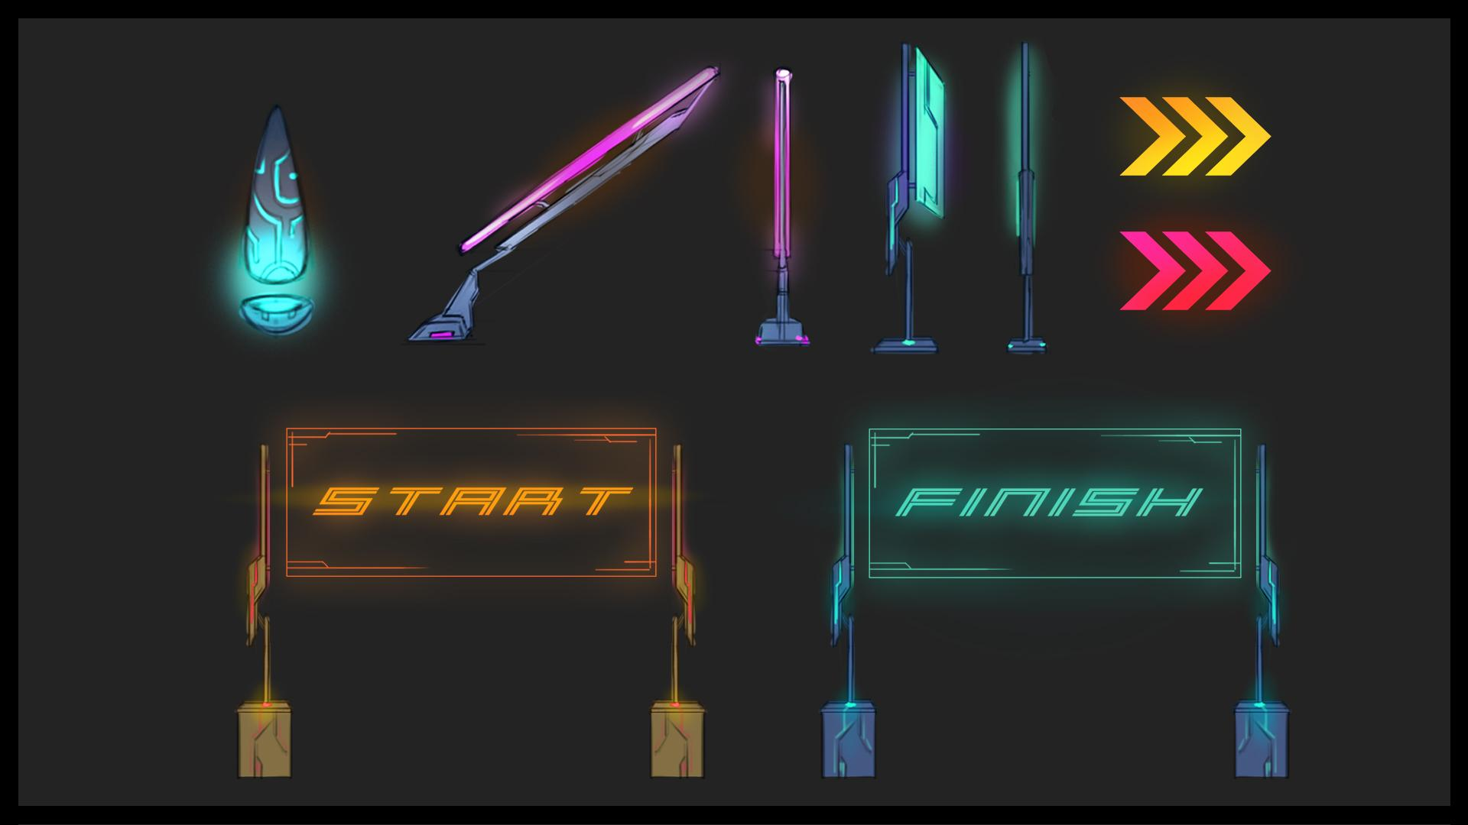

**Signage**

Signs are an easy way to convey direction. Even signs without words can point players in the right direction with a pop of color or a flash of light.

Though environmental elements like restaurants, shops, etc. will have words in made up languages from each planet, **words like “Start” and “Finish” will be printed in English for ease of understanding.**

**Lighting**

Lighting helps distinguish the track from the world surrounding it. Players will follow light, so making the track exceptionally bright will help players understand where it is. Lighting color and intensity may change from level to level, but **the principle of having the track be more brightly lit than its surroundings should be constant.** 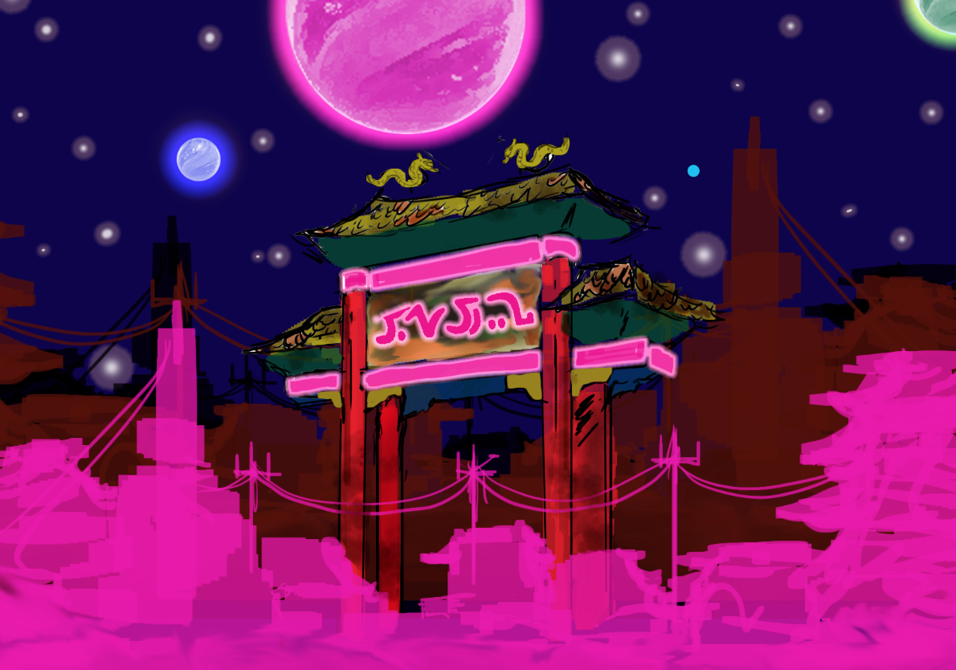

**Hero Pieces**

Hero pieces are large artifacts that draw the player’s attention during the race. They are usually part of the environment, whether manmade or natural. Hero pieces help orient players by giving them something to consistently compare their position to. **To avoid confusion and clutter there should only be one hero piece in each level.** Hero pieces should be visible in some capacity for about 30% of the race.

**Landmarks**

Landmarks are unique geographical or manmade features that help the player orient themselves in the game world. They are not as large as hero pieces, but are still important to help players understand their position in the world. **There can be infinite landmarks in a level, so long as they are distinguishable from one another.** 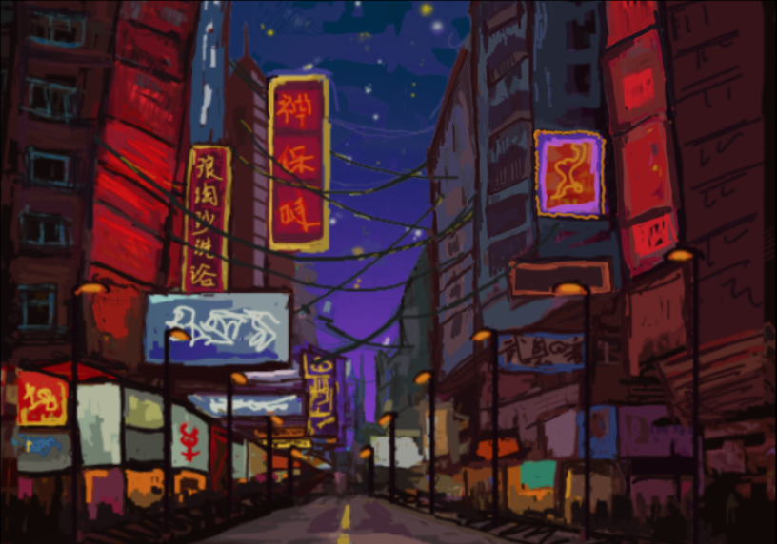

**Landmarks are a useful tool for marking progress along the track as well as for noting the locations of shortcuts.**

**Hazards and Pickups**

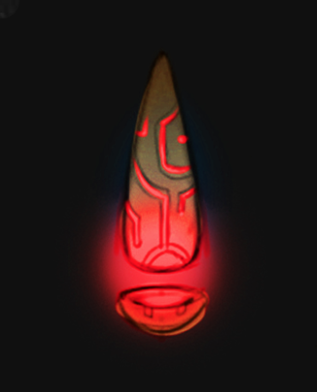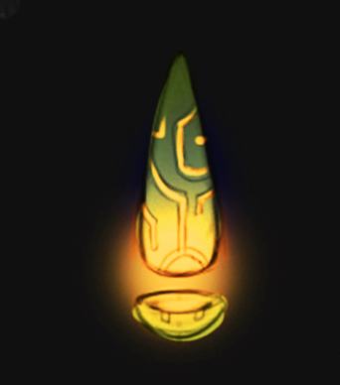

**The same color will be applied to all track hazards regardless of what level they are in**. This will help with conveyance across multiple levels. We are waiting on a style guide from the artists to choose a color. Typical colors associated with hazards are red, yellow, and orange.

Clayton’s badass art

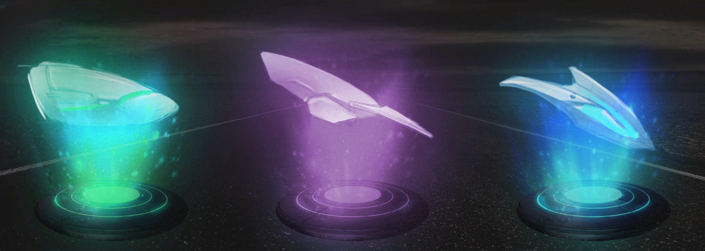

The color rule also applies to pickups and gates. **Each type of pickup (there are 2) will have an associated color. These will also remain consistent across the levels to help with conveyance.** Artists will determine the colors.

## 

# Environments

## Level 1 & 2

**Futuristic City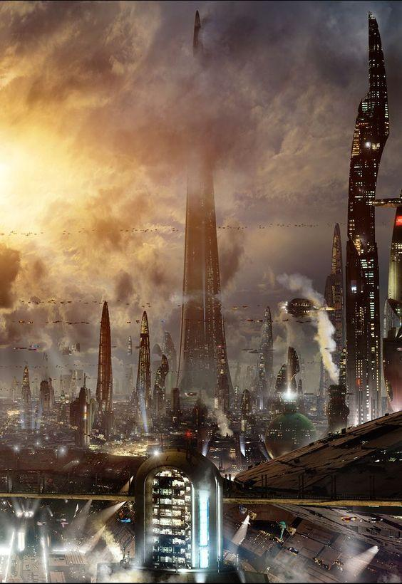 – Slums & Downtown**

**One sentence overview:** Players race through a city’s crowded market, run-down slums, and flashy downtown district.

**Descriptors:** Compact, neon, grungy, vertical, disused, towering

**Scale:** Player is very small compared to their surroundings. Buildings tower overhead. This level should feel vertically massive.

**For reference:** *Blade Runner 2049, Ghost In The Shell, Ready Player One* (movie), *Shadowrun Returns*

Level 3 & 4

**Desert Wasteland & Oasis**

**One sentence overview:** Players race across a vast desert to reach a finish line situated in the middle of a lush oasis town.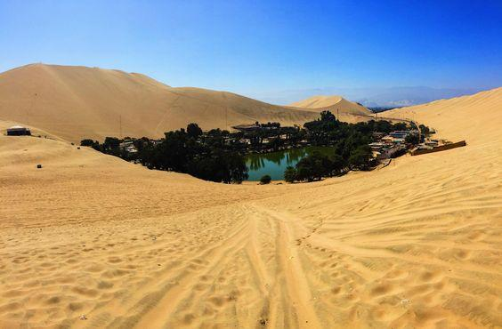

**Descriptors:** Barren, wasteland, contrast, oasis, pristine, wide, expansive

**Scale:** The desert should feel horizontally massive, but the buildings of the oasis town should feel like small houses. The player’s car will be scaled to them the same way a car is scaled to an average two story house on Earth.

**For reference:** Huacachina (Peru), *Dune* (TV), Tatooine (*Star Wars*), Marrakech (Morocco), Sahara desert, *Mad Max: Fury Road*

# User Interface:

**Menus Flowchart:**

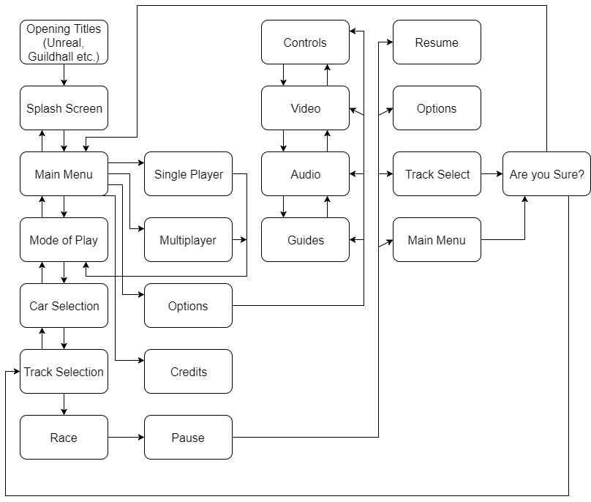

**Main menu**

Main Menu with buttons:

1. Single Player

2. Multiplayer (Selection of Players attached to button [INSERT IMAGE INSPIRATION]

3. Options

4. Credits

For all menus : A is select, B is go back, Control stick flips between buttons

Player 1 controls all menus except for Character Select and Track Select

**Single Player**

Single Player Menu with buttons:

1. Tournament Mode

2. Time Trials

3. VS

**Multiplayer**

Multiplayer Menu with buttons:

1. Tournament Mode

2. Time Trials

3. VS

**Options**

Options takes a player to same options screen as beginning.

**Credits**

Credits for team.

**Mode of Play Screen**

**Tournament Mode**

This is a tournament mode designed to race the cars in a standard cup format.

**Time Trials**

This is a mode designed to race against your previous time to practice a track in terms of handling the track (perhaps against a ghost).

**Ghost is cut.**

**VS**

This is a mode designed to allow a player to play against 1 or more CPUS, purely to play the track with no consequences against players

**Character Select**

Character Select Screen with 4 cars.

Character concept on left side, with associated character.

Allow overlap of cells to create a punchy aesthetic.

Cars depict Stats above car image on right hand side.

When multiple players control the menu at the same time, selection features will be colored to reflect the player and 1, 2, 3, 4 will be depicted.

**SubOptions Menu**

This menu is for additional modifications to our car. If modifications exist they go here.

**Track Menu**

This menu is for selecting 1 of our 4 tracks. Each cell that contains a track will show a card showing the track. Information for the track will appear here. In Tournament Mode, this menu does not appear.

**Start Race**

Race begins after track selection and loading. From here forward START is what allows a player to quit the track via the pause menu.

**Pause**

The pause menu covers the screen in the middle with the options:

1. Resume

2. Options

3. Main Menu

In multiplayer if a player selects the pause button the screen depicts who it was, and the pause button remains in the middle of the screen.

**Resume**

Resume allows a player to unpause. If you mash B you will select this.

**Track Select**

Track select allows a player to go back to the track select, and therefore be allowed to B back through all menus. If selected it will ask if you are sure with a Yes or No

**Main Menu**

Main Menu will take a player to the title screen. If selected it will ask Yes or No.

**Load**

The load screen shows up between loading intervals. This screen will show character art or car art as necessary.

**Options**

Options Menu with buttons:

1. Controls

2. Video

3. Audio

4. Guides

**Controls**

This menu exists to show players the control scheme via an XBOX ONE Controller with diagram and descriptions.

There is an option for control schemes (if more than one.)

There is an option for customization (to remap buttons on demand.)

**Video**

The video options menu exists to operate

1. Gamma

2. Saturation

3. Resolution

**Audio**

The Audio menu allows a player to turn off or modulate the volume on a number of audio elements:

1. Main volume [all volume items manipulated]

2. Music volume [Track music volume]

3. Sound volume [Car noises, track noises UI noises etc.]

**Guides**

The guides menu exists to show basic guides for the varieties of thing in the game. Think of the booklet that comes with the game.

This menu is split into

1. Item Descriptions

2. Car descriptions

3. Track Descriptions

4. Movement guides

**Item descriptions**

Item descriptions will show the varieties of pickups in the game,

What they look like

What they do

What they are

**Car descriptions**

The Car descriptions menu will show the varieties of car in more detail:

What they look like

What they do

What they are

**Track Descriptions**

The Track Descriptions menu will show the varieties of track in more details

What they are

Basic hazard info and difficulty, with special features.

**Movement guides**

The Movement Guides menu will show the varieties of way the car can move, and what controls operate that movement.

_____________________________________

User Experience

## Controls

### Race Controls

### 

### 

### 

### 

### 

### Menu Controls

# 

# Characters

Each car will have an associated character. These characters will be displayed on the car selection screen along with the car. Each character should have a distinguishable silhouette and a unique personality that is conveyed through their expression, pose, and costume.

**Character Design Principles**

**Archetypes**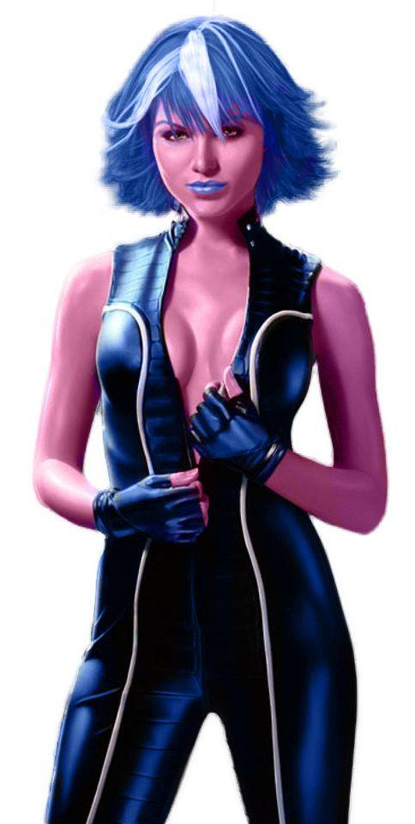

Lean into science fiction/fantasy clichés as much as possible. Have fun with it and make it dramatic! Don’t go halfway with creating a character to represent an existing archetype. Consider archetypes like:

* Genius
* Womanizer
* Hot girl
* Tank
* Smartass
* Bigshot/Hotshot
* Cyborg
* Alien
* Motorcycle girl
* Scrapper
* Underdog
* Privileged
* Champion
* Lolita (cutesy) girl
* Hacker
* Child

Look at *Borderlands, Redline*, *Ghost in the Shell* (2017), *Blade Runner 2049, F Zero,* and *Neon Genesis Evangelion* as examples of where these character archetypes are used.

**Design considerations**

* Equal number of male and female characters. 4 and 4. OR 3 male, 3 female, and 2 gender-neutral/androgynous characters.
* At least one character from each of the planets visited during gameplay.
* Among distinguishably human characters there should be a visible race spectrum.
* Among non-human characters watch out for any features that could be construed as racial/ethnic stereotypes.
* Avoid costumes and characters that could be construed as political commentary
* Be aware of sexism. It’s not wrong to have a woman in a skin-tight bodysuit if you have a man in one too. A character’s *personality* should affect how they dress, not their sex and gender.

# Technical

## AI

The game will have a maximum of 7 AI running during any race. These AI compete with players for the first place position. 2 AI should be competing for first place, while the rest of the AI are competing for latter places.

### Rubber Banding

Players gain more stats when not in first place. So, players in first place have base stats, and the other places have improved stats.

|  |  |  |
| --- | --- | --- |
| **Place** | Top Speed Modifier | Acceleration modifier |
| 1st | 0 | 0 |
| 2nd | 7% | 1% |
| 3rd | 14% | 2% |
| 4th | 21% | 3% |
| 5th | 28% | 4% |
| 6th | 35% | 6% |
| 7th | 42% | 8% |
| 8th | 50% | 10% |

## Backpack

## Physics

### Freefall

Vehicles can enter freefall while on tracks and tracks can be designed to allow this. However, a track cannot have holes. Players must, at all times, have track below them somewhere.

Example:

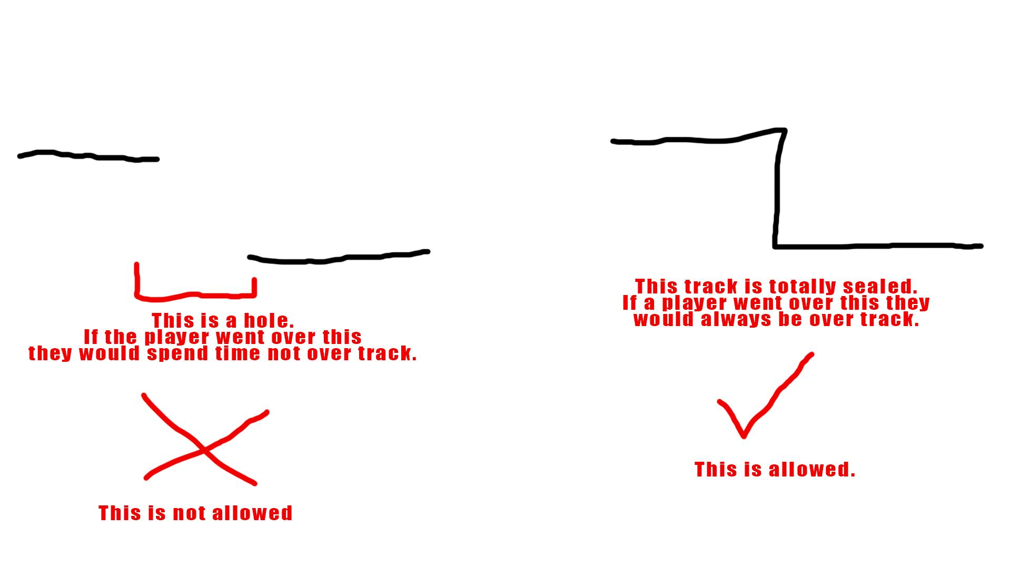

### Colliding with barriers

When the player collides with a barrier they should grind along it for a time until the player steers their vehicle away from the barrier.

Diagrammed Below:

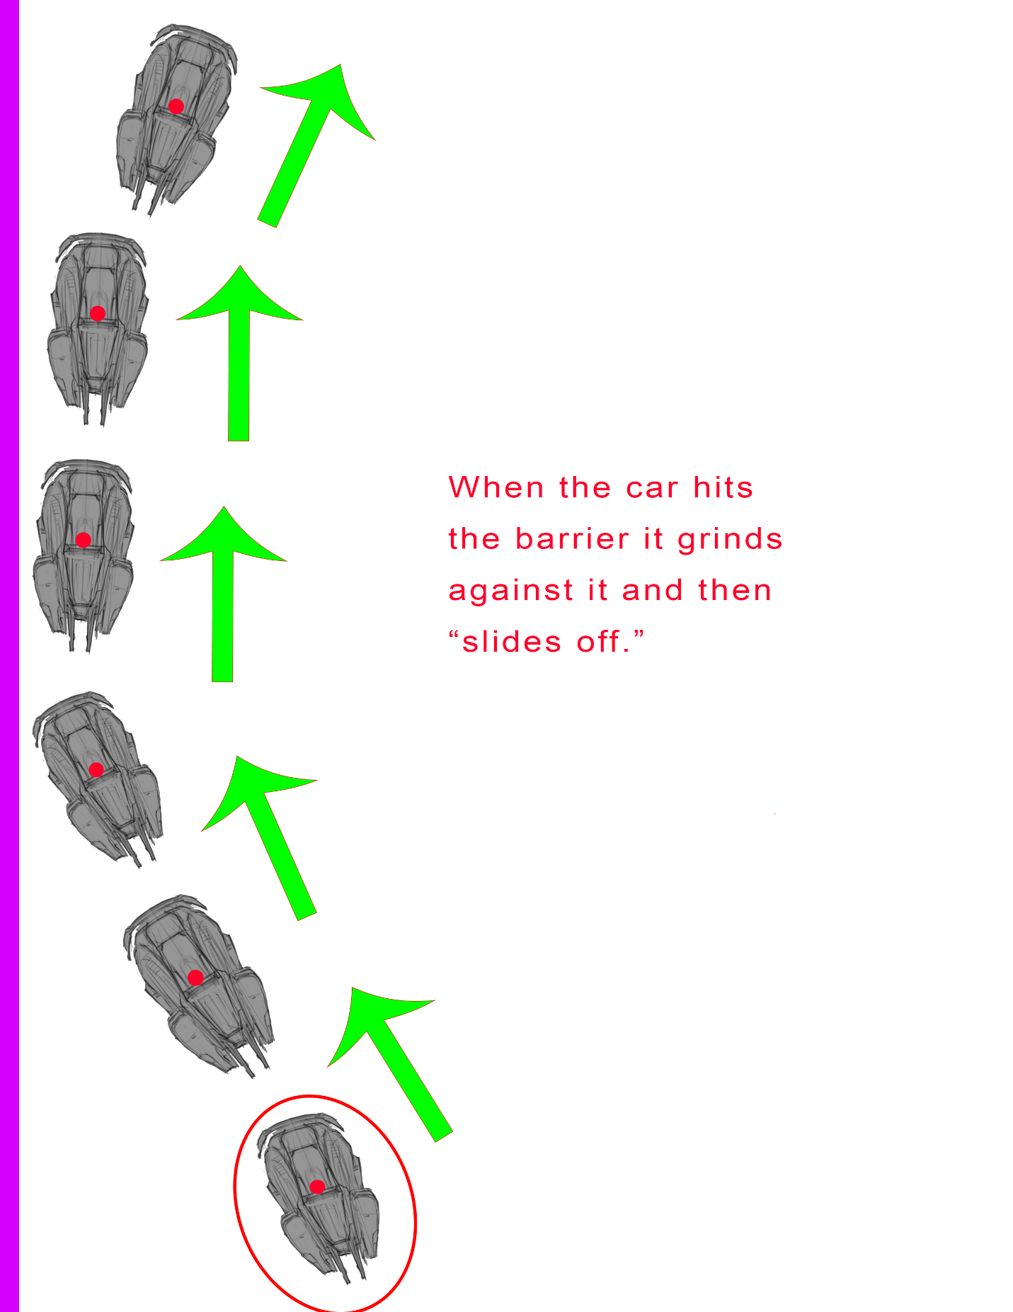

* “Sliding Off” refers to the player steering away from the barrier.
* This behavior holds true in the air as well

### Camera

The camera will always be looking at where the player is going. It should be adapting based on the player’s turn to provide the player with visual information about what is coming up on the track.

Diagram:

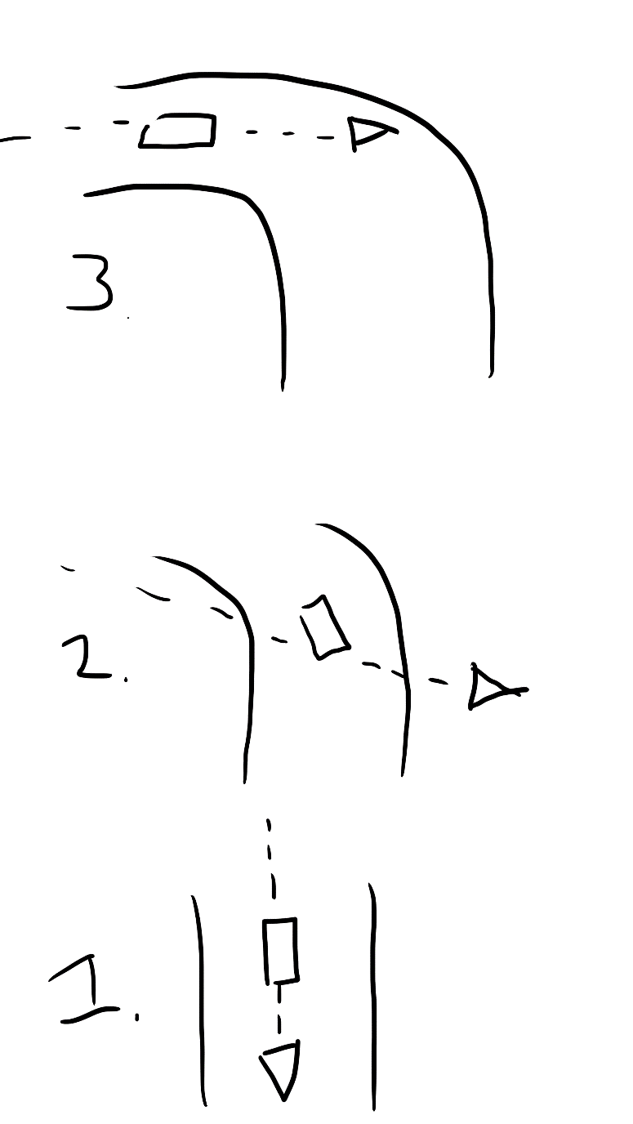

The car is the rectangle, the camera is the triangle. The dotted line is approximately where the camera is looking.

The camera needs to be looking **ahead** of where the car is to give the player time to react to what is on the track.