Level 1 - UNWelcome

## Legend

This is an empty tile. Players can summon demons on this and neighbors can path over it and be moved over it by any demon.

This is the neighbors main path. Neighbors will move along this path until they are moved off of it by a demon.

This is the neighbor's starting tile. Neighbors spawn from here.

This is an exit tile. Neighbors will be removed if they touch this tile.

This is the Witch's tile. The neighbors are trying to reach this tile.

These are obstacle tiles. Neighbors cannot be moved through these tiles or path through these tiles. Only a spring demon can move neighbors over these tiles.

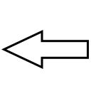

This arrow shows the general direction players are intended to be moving neighbors in. Players can move the neighbors in whatever way they choose, but the direction the neighbors move in should be heavily incentivized for the player. Players should want to move neighbors in these directions because those are efficient ways to move the neighbors to the exits. The arrows are not placed into the hand held tutorial levels since players are required to place demons in specific locations.

This box shows the general zones players should be thinking about when creating demon setups. Designers should get players to look at these areas as opposed to thinking about the whole map at once.

The blue space is space being used for the background art.

# Level 1 Layout

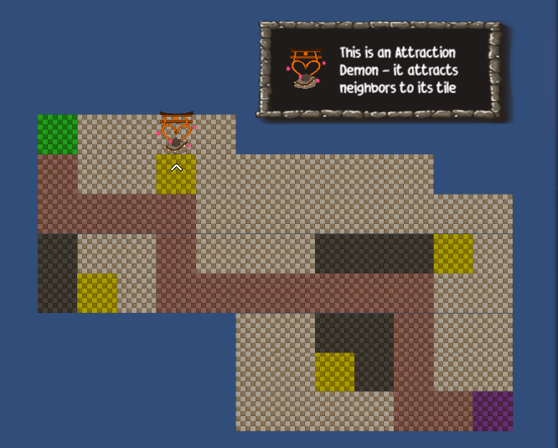

# Level 1 Final Art

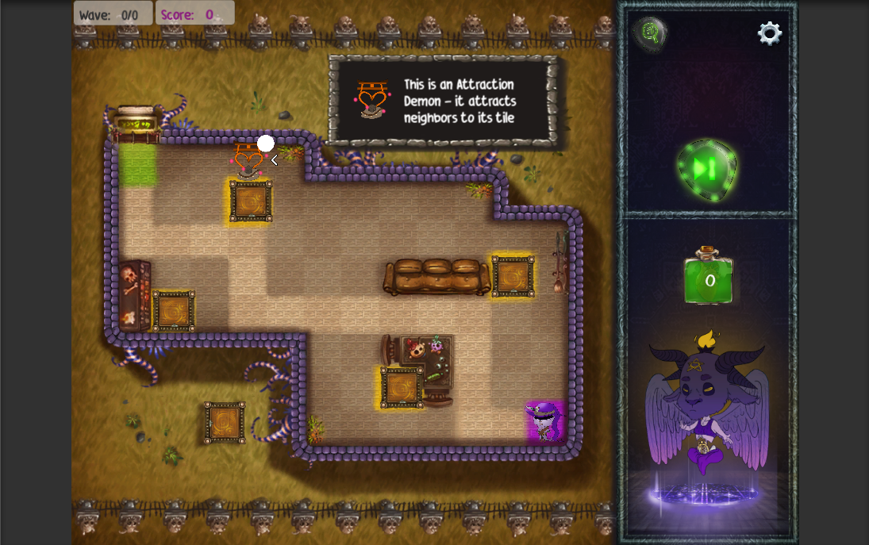

# Level 1 Flow

Level 1 is similar to the "normal" levels, except a text tutorial explaining the mechanic of the attraction demon is present in this level. There is also a pre-placed attraction demon in the level to show how it works and teach players about the attraction Demon.

# Design Choices

This level is partially a tutorial and partially a standard, simple level. This level was created late in development because our 2nd tutorial was not effectively teaching spring demon mechanics and attraction demon mechanics. I split the attraction demon off onto its own level because of this.

Players were also struggling to learn with our original tutorial levels, so I implemented a new style of tutorial to try and find a more effective teaching system. This was a successful change. Players remembered the Attraction demon much better than they had before, however the spring demon as still not taught well enough and players began struggling with spring demons more.

This level also only uses teleporters as exits to teach the players about teleporters as an exit. Midway through development we needed an exit that was not attached to a wall, so our artist created a teleporter. However, since players were struggling with exits other than the windows, this level was also created to teach players about teleporters.

The text box was placed towards the upper right of the screen to keep it close to the pre-placed demon and help it remain associated with the pre-placed demon.

This level was kept mostly open to allow players to practice with demons more. The simple removal paths also helped this goal. Players could move neighbors to the exits with only 1 demon for a majority of the exit. The exits towards the end of the level required a combo though, to help reinforce the combo mechanic.

# Artistic Choices

This level was envisioned as a small outer shack for testing magic away from the witch’s house. It is not connected to any other building and features only teleporters. The grass was selected as a dead color to keep the players focus on the inner area, since this level features far more grass than most. The contrast between the dead grass and brighter colors of the play area keeps the players interested in the play area. The bright purple roofing serves as a strong border in the player’s mind.