Dictionary

Note: This is all in the context of our game. Much of this is inspired by real world terms though.

Alternate names are placed in parentheses next to the term.

**THIS IS A LIVING DOCUMENT. ALL IS SUBJECT TO CHANGE.**

# Acceleration -

* The rate at which a vehicle increases its speed. Measured in meters per second squared. ()

# Apron –

* Asphalt/concrete between track and infield

# Booster –

* Creates extra thrust for the vehicle to add speed. A secondary source of forward momentum.
  + Separate from the Engine

# Boost knocking -

* Hitting another player’s car while boosting. This causes the other players vehicle to be knocked out of the way. This causes a much more dramatic knockback effect than if the colliding vehicle was not boosting.

# Bottoming –

* When the bottom of the Chassis hits the track.
* This is not planned as a mechanic.

# Braking -

* The player’s ability to quickly decrease their speed

# Catch Fence (Catch Field) -

* A barrier of some kind that prevents cars from flying into the crowd.
  + In our game this will take the form of an energy force field.

# Chassis –

* The base frame of the vehicle. The outer frame is placed on top of the chassis. (On a wheeled vehicle the axles, and subsequently the wheels are attached to the chassis.)

# Chicane -

* An unnatural curve in a track or road designed to allow for passing or to cause vehicles to slow down. These curves are not dictated by geography. They are completely artificial.
  + A classic example of this is an S bend

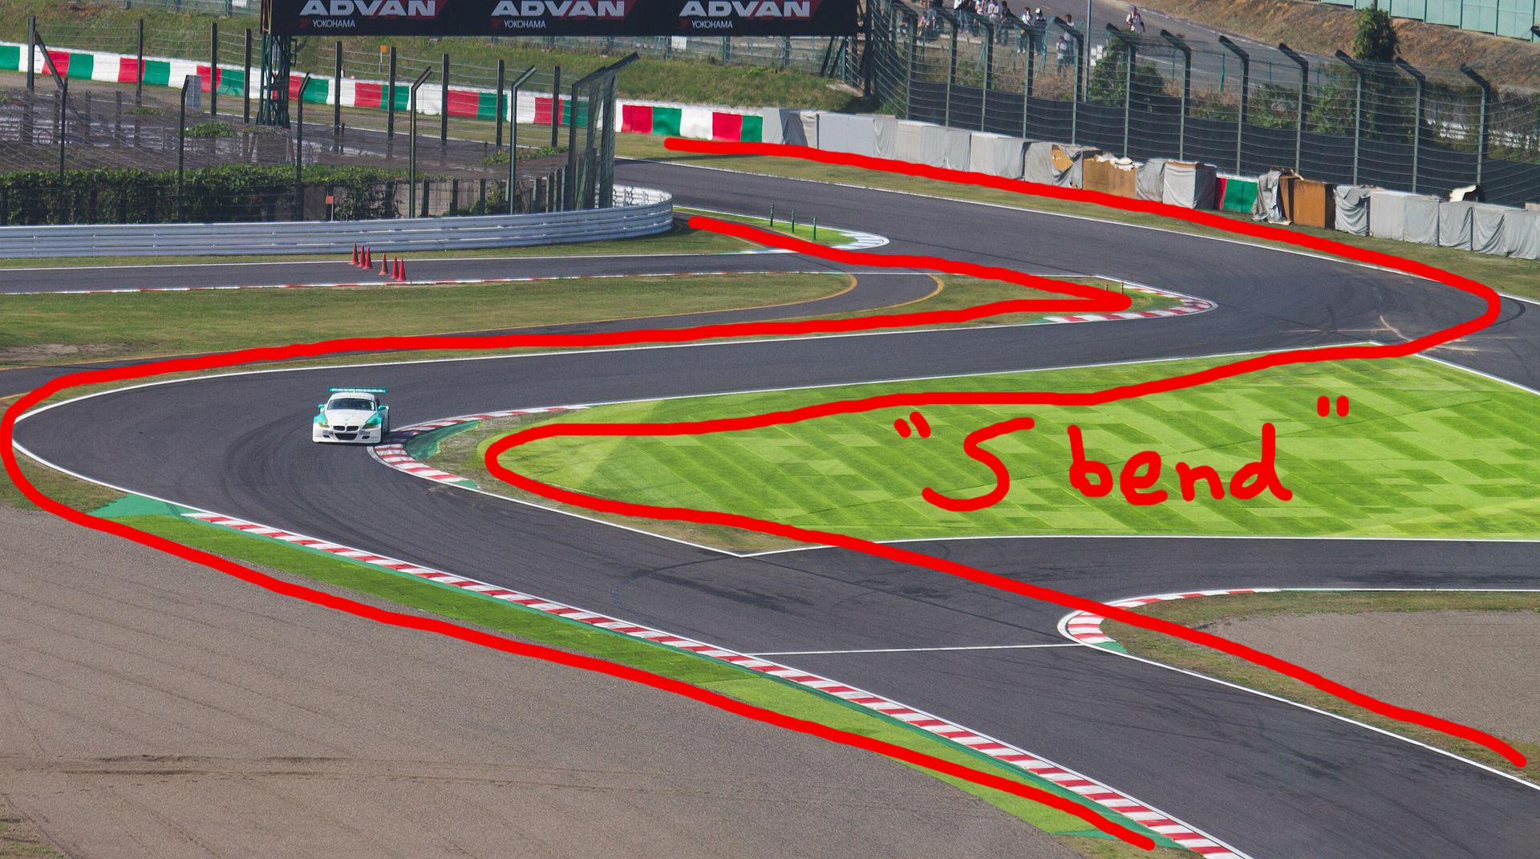

# Christmas Tree (Starting Lights) -

* The set of lights that let the racers know when to begin.

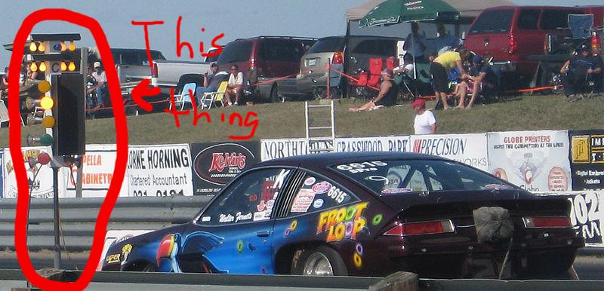

# Drift -

* Allows players to take turns more tightly.
  + Mostly used to take turns with a higher exit speed/at higher speeds.

# Downforce -

* Force holding vehicle to track
  + For us this will likely take the form of magnets or something.

# Energy –

* **To eliminate Integrity/Boost confusion we will now be using the team ENERGY**
* Vehicles have a certain amount of energy
* Vehicles spend energy to boost
* Vehicles lose energy when running into objects and other vehicles
* Vehicles will spin out, slow down, or die (we have not decided yet) when they run out of energy.

# Engine –

* Create thrust for the vehicle. The main source of forward momentum.

# Exit Speed -

* The player’s speed when coming out of a turn.
  + Players want to maximize this number when playing.

# Fastest Lap -

* The lowest time in which a lap was completed by a driver.

# Flag-to-Flag coverage -

* Television or radio coverage consists of the entire race.
  + This is a spectator sport so every race has Flag-to-Flag coverage.

# Frame -

* The basic ‘car’ selected by the player before racing. This determines the player’s character and the vehicle’s weight.
  + The outer part of the car.
  + The pickups will be attached to this

# Gap -

* The amount of distance between two racers.

# Grid -

* The starting formation of a race.
  + E.g, Cars are in two columns with two cars per row

# The Groove -

* The optimal path around the track

# Hairpin -

* A tight 180 degree turn that loops back around.
  + A hairpin turn always starts in one direction and ends going back the way you came from. (Think of it like starting in the +x direction and ending in the -x direction.)

# Handling -

* A player’s ability to move through turn at speed
  + A car with higher handling can take turns at higher speeds without losing control or colliding with an obstacle

# Hero Piece -

* Very large environment pieces. They dominate the landscape and can be used by players to help orient themselves in the playspace. Only 1 hero piece is present per level.

# Infield –

* Area that is inside of the track
  + This area is generally enclosed by a fence or not intended to be raced on.

# Integrity -

* The car’s ‘health bar’. This determines the player’s ability to boost. Boosting consumes integrity at a fixed rate.

# Landmark -

* These are unique, visible, and easily remembered environment elements. Landmarks are smaller than hero pieces but can be sued by players to help understand the progression along the track. Landmarks can be used to cue the player into important track elements (e.g, shortcuts, or major track elements)

# Lap Record -

* The fastest record time for a single lap on the track.
  + Different vehicles have different lap records recorded

# Lifting -

* When the players lets off the gas to lose speed
  + As opposed to braking the only thing reducing the player’s speed is drag, not another force
  + Reduces speed significantly less than braking

# Oversteer -

* Turning the wheel has a greater effect than expected
  + In our case this will mostly refer to something on the track affecting the car since we don’t have wheels that wear out (for example)

# Pickups -

* Objects players can gain that affect their vehicle. These are picked up by driving over them and remain on the car until spent or changed.

# Privateer -

* A competitor with no sponsor

# Ripple Strip -

* Concrete kerb, usually placed on the inside of a corner, painted in chunks of colour, usually red and white alternately

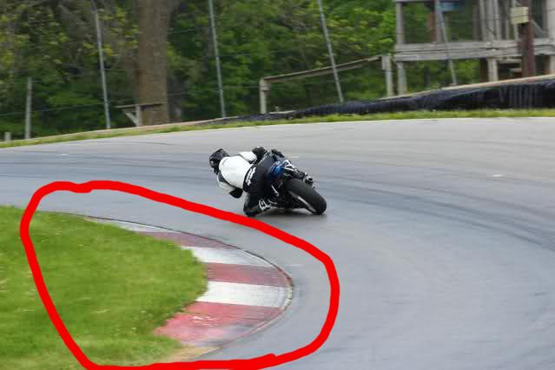

# Rocket Start -

* Players can get a boost at the start of the race by pressing and holding the accelerate button at a specific time. If failed the player is unable to move for a few seconds after the race starts.

# Rolling start -

* Players start the race at full speed.
  + The vehicles have been moving beforehand and have reached max speed by the time they hit the starting line.

# Speed -

* The rate at which a vehicle crosses distance. Measured in km/h.
  + This is almost the whole point of the game. Gotta go fast.
  + Unlike velocity this does not require a direction.
  + Speed is shown to the player. Velocity is not.
  + “How fast is this object moving”

# Starting Line/Lap Line/Finish Line -

* All three of these are the same location but the terms are used for different parts of the race.
  + Starting Line - Before the race begins
  + Lap Line - During the Race, but before the final lap
  + Finish Line - Final lap

# Standing Start -

* Players start the race with 0 speed

# Spring –

* A type of track piece. This track piece spins around an axis in a corkscrew or spring shape. Players are only able to drive on the inside of the spring.

# Track -

* The surface you race on

# Thruster -

* On our rocket cars this is placed on the back of the vehicle and creates thrust to push the vehicle forward.

# Understeer -

* When turning the wheel has less effect than expected
  + In our case this will mostly refer to something on the track affecting the car since we don’t have wheels that wear out (for example)

# Vehicle (Car) -

* The thing you drive

# Velocity -

* The rate at which an object changes its position.
  + Requires a direction
  + Is a vector quantity
  + Velocity is not shown to the player, speed is shown to the player