Enemy Designs

|  |  |  |  |
| --- | --- | --- | --- |
| **Version #** | **Changes made** | **Made by** | **Date** |
| 1.0 | Initial Document creation | Blake Philley | 26/09/2018 |
| 1.1 | Changed “swarm” to “bunch” for clarity | Nicholas Thomas | 27/09/2018 |
| 1.2 | Added in section for conveyance | Blake Philley | 28/9/2018 |
| 1.3 | Turret enemies are cut. Reworking enemy language to reflect use of only light enemies. Spawner and Laser moved into this document from medium enemies. Charger rolled into chaser. | Blake Philley | 30/9/2018 |

## Basic AI Features

### Movement Behavior

Every AI attempts to move into a ring around the player. Until the AI is within this ring it will not be aggressive. Once inside the ring the AI is aggressive and begins firing at the player or attempting to damage them.

#### Player Healing

The player can only regain health by killing enemies. This reinforces the push-forward combat that Mitchel has described. The combat loop for the game involves only killing enemies so forcing the player to heal by killing enemies keeps them inside this loop even when their priorities during combat change.

The Healer enemy heals the player for much more than a standard enemy. A standard enemy heals for about 5% of the player’s health, while a healer gives about 50%.

## Enemy Types

|  |  |
| --- | --- |
| **Archetype** | **Design Description/Purpose** |
| Aggressive | Tests the most skills out of all the light enemies. Aggressively chases the player down and tries to bunch together to kill the player. |
| Healer | Will always heal the player on death. Tries to stay away from the player and does not attack very aggressively. Weak guns, and somewhat slow movement. Not very dangerous. |
| Turret | ~~A stationary enemy type. Fires weapons from a static position. Will always shoot at the player if the player is in range. Somewhat dangerous.~~ Cut |
| Chaser | Uses a damaging AoE knockback attack. Chases after the player but is not very dangerous. Charges at the player from a specific range. |
| Spawner | Has no weapons of its own but spawns other robots to fight the player. Spawn number is limited and can only spawn up to a certain number. |
| Laser | Uses a laser beam to fire at the player from a long range. Has a shield in front itself. Can only be killed from behind. |
| Bonus | ~~Does not fight the player. Very fast and evasive but gives a lot of points when killed. Only active for a certain amount of time before disappearing.~~ Cut |

### Aggressive

Basic Behavior:

* Bunch in front of the player
* Fire Weapons
* Overwhelm the player

Player skills this enemy tests:

* Jump
* Slash
* Dash
* Deflect

Enemy Behavior:

The aggressive enemies attempt to bunch together to defeat the player. They do this by attempting to move into a specific radius around the player, then moving into the correct firing area.

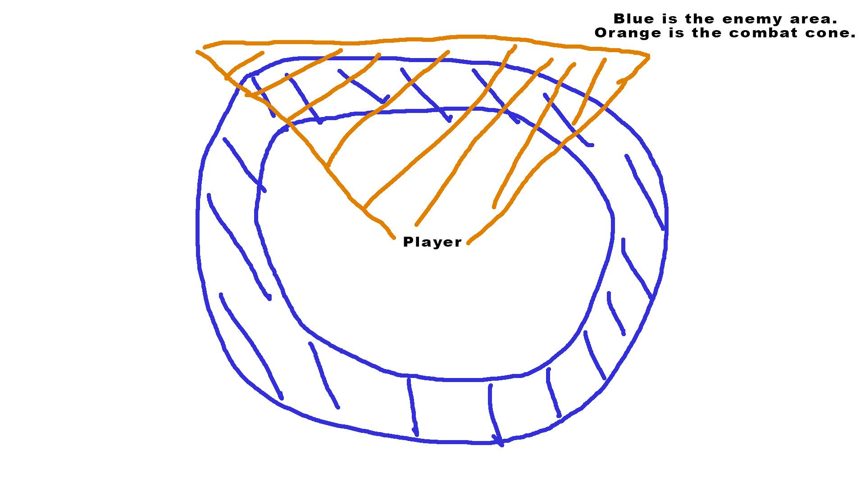

The aggressive enemy wants to be in the blue and orange area at the same time.

The aggressive enemy’s accuracy is determined by how close it is to that combat cone. If it is inside the combat cone it is fairly accurate (something like 70% accuracy) outside that cone it becomes less and less accurate until it reaches basically 0% when directly behind the player.

These enemies want to bunch into the combat cone area, but we can’t just let 20 enemies all be dangerous at the same time. The purpose behind this behavior is to cause the player to feel that the situation they are in is more dangerous than it actually is.

### Healer

Basic Behavior:

* Stay Away from the player

Player skills this enemy tests:

* Jump
* Slash
* Dash
* 3D Movement

The Healer enemy wants to stay away from the player. It has weaker weapons than the aggressive enemy, but it will consistently heal the player when killed. This enemy is also slower than the aggressive enemy. We want the player to intentionally chase these ones down. The player generally moves through a very fast loop of Attack -> Plan during combat. This can help shake up the players plans, depending on their health value. It gives the player an opportunity to be making tactical decisions at all times.

### ~~Turret~~

~~Basic Behavior:~~

* ~~Aim at the player~~
* ~~Fire~~

~~Player skills this enemy tests:~~

* ~~Slash~~
* ~~Dash~~
* ~~Deflect~~

~~This enemy is totally stationary. It fires on the player whenever the player gets in range. This enemy should be less dangerous than the aggressive enemies, but not so weak that it can be ignored. This enemy can be equipped with basically any gun, but will likely use lasers and grenade launchers more frequently.~~ Turret enemies are cut

### Chaser:

Basic Behavior:

* Encircle the player
* Chase the player

Player skills this enemy tests:

* Slash
* Dash
* Dodge
* Corralling

This enemy does minimal damage and is not as fast as the player. The intention for this enemy is to disrupt the player’s planning by charging at them and aggresively chasing them from melee range. It uses a damaging AoE knockback attack. This AoE is weak, and doesn’t push the player too far, but it is still a problem to be considered. It can be used to help interrupt the player’s combat flow. It forces the player out of their original plan and they must reconsider the combat on a moment to moment basis.

Chasers have two rings they utilize: one for the AoE damaging ability and one for the charging ability. The charge is much farther away from the player than the AoE blast. The enemy will charge forward towards the player on a fixed path from the outer charging ring. The fixed path allows the player to dodge it once activated and charging. The charge deals high damage and has a large knockback associated with it.

### Laser

Basic Behavior:

* Slow Movement
* Charge Laser
* Sweep Laser

Player Skills this enemy tests:

* Maneuverability
* Dash
* Focus
* Dodge

This enemy is comparatively very stationary. It spends most of its time charging its laser to be fired at the player. The laser does high damage when contacting the player. The laser does not fire immediately but has to be charged before firing. After a full charge the enemy will begin firing the laser at a point away from the player. After waiting a second the enemy will sweep the laser across the field in an attempt to hit the player. This Charge -> Wait -> Sweep behavior is very important. The player needs time to understand and react to the laser’s movements. It has been diagrammed below for clarification:

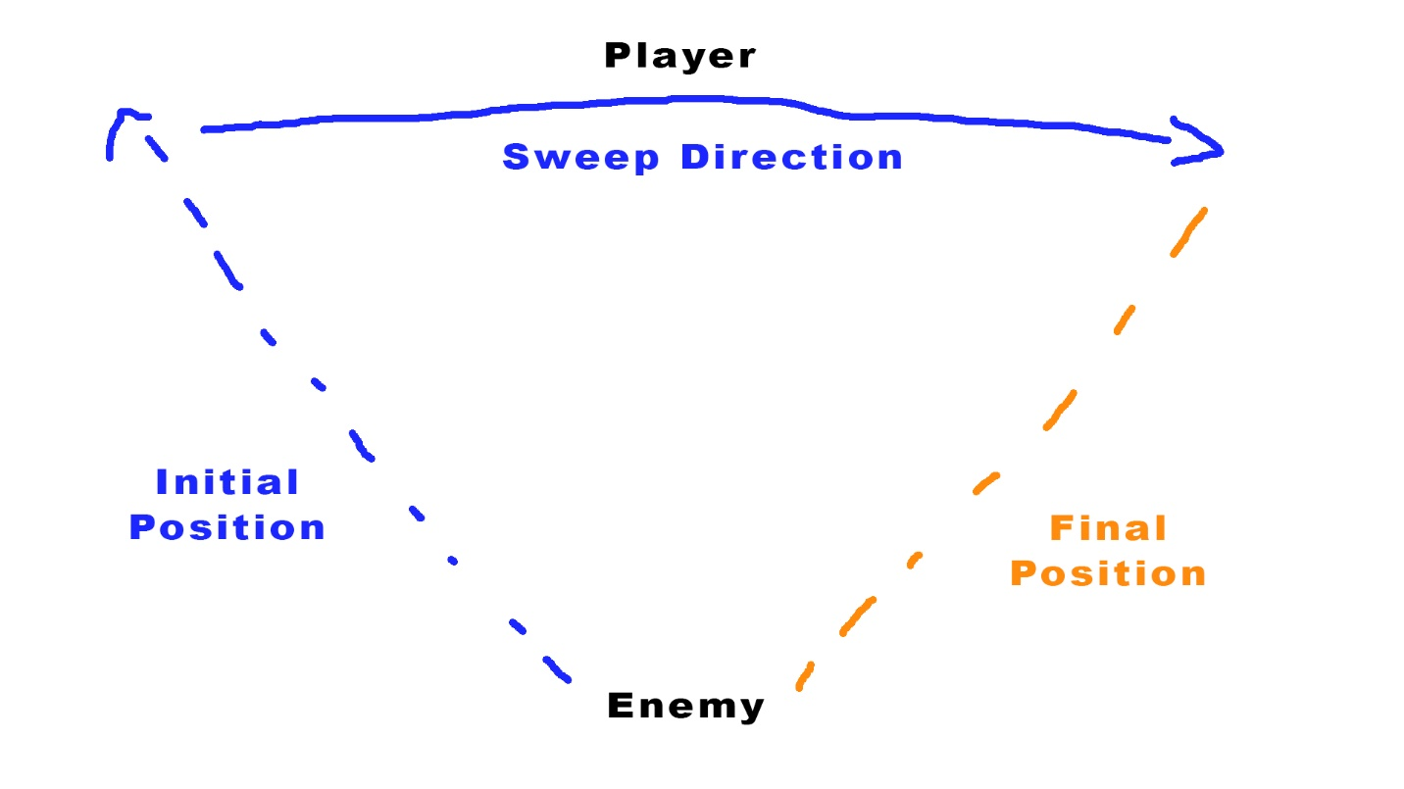

### Spawner

Basic Behavior:

* Slow Movement
* Spawn other enemies

Player skills this enemy test:

* Quick thinking
* Dash kills
* Prioritization during combat

The spawner enemy is the physically largest of all the enemy types. It has no weapon of its own but instead spawns more enemies. These spawns occur at a fixed rate and up to a certain number. Once this number has been reached the spawner does nothing. When about to spawn an enemy a beam is shot towards the ground to convey to the player what is happening. The spawner enemy is the highest priority for the player to kill, otherwise the player will quickly become overwhelmed due to the number of enemies now in the space. Be careful with how many of these are placed in a level as they can become stuck or cause frame rate issues since so many enemies will be present.

What enemy will be spawned is based on a random chance. The important chances here are that healers must be a low spawn chance and lasers are also at a lower spawn chance. If we give the player a lot of healers the game will quickly become too easy, and too many laser enemies can become a problem for framerate with their shield material.

## Conveyance

This section details how the differences between the enemy subtypes will be conveyed. The enemy will hopefully be conveyed to the player before it fires at the player. (Teaching the enemy’s behavior isn’t something we can convey until it interacts with the player, so focus on using this conveyance under the assumption that the player already knows the behaviors, but needs to know which enemy does what during combat)

In general the broad conveyance tools are:

* Color
  + Each enemy subtype uses a different main color from the others.
  + This is intended to convey quickly, and especially during motion.
* Size
  + Enemies can be slightly resized according to their subtype.
  + This is intended to help convey quickly from a distance especially.
* ~~AI Movement Behavior~~
  + ~~The different behaviors of each of the AIs should help convey which is which.~~
    - ~~For example, the aggressive enemy flies, while chasers do not. The aggressive enemy is fast, whereas the healer enemy is slow.~~
  + ~~AI behavior is a layer on top of the other conveyance measures, it is not enough conveyance on its own.~~
    - ~~It should be more valuable for more skilled players, and therefore more useful for players as they progress through the game.~~ Cut, all AI use the same movement behavior

Conveyance tools:

* ~~Unique meshes per subtype~~ Cut
* Unique sounds per enemy

|  |  |  |  |  |
| --- | --- | --- | --- | --- |
| **Aggressive** | **Healer** | **Chaser** | **Laser** | **Spawner** |
| * Red color * Darting Movements | * Green Color * Plus sign particle effect | * Blue color * Charging sound * Charging Particles | * Charging Particles * Shield Material * Laser Charge * Yellow Color | * Charging Effect * Larger Size * Orange Color |