UNWelcome - Tutorial 2

# Legend

This is an empty tile. Players can summon demons on this and neighbors can path over it and be moved over it by any demon.

This is the neighbors main path. Neighbors will move along this path until they are moved off of it by a demon.

This is the neighbor's starting tile. Neighbors spawn from here and move along the main path after spawning.

This is an exit tile. Neighbors will be removed if they touch this tile.

This is the Witch's tile. The neighbors are trying to reach this tile by proceeding along the main path.

These are obstacle tiles. Neighbors cannot be moved through these tiles or path through these tiles. Only a spring demon can move neighbors over these tiles.

The blue space is space being used for the background art.

# Tutorial 2 Layout

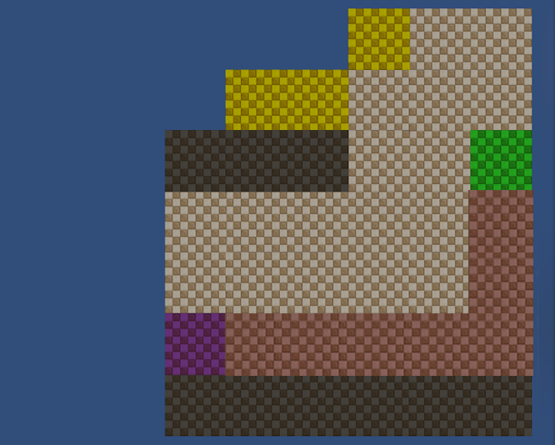

# Tutorial 2 Final Art

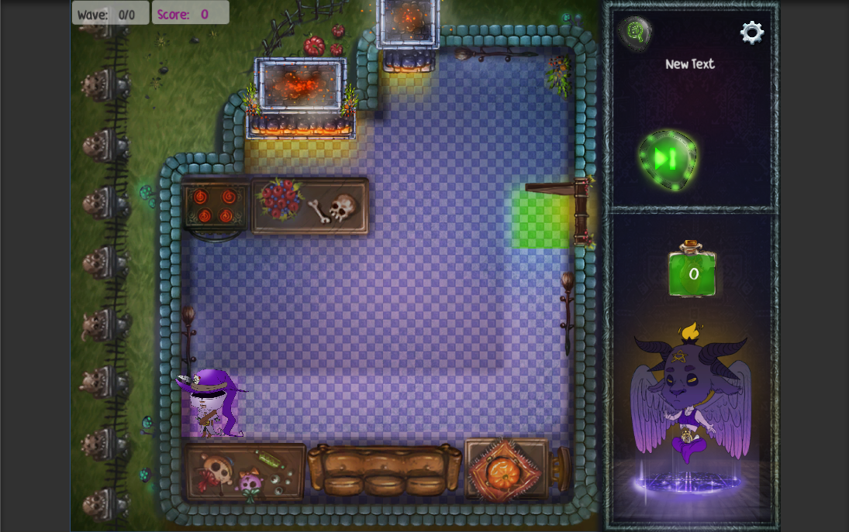

# Tutorial 2 Flow

Tutorial 2 is also a hand-held experience. Players are walked through all the necessary steps to learn the following skills:

* Neighbors being pushed off the main path
* Summoning demons on and off obstacles
* Spring Demon mechanic
* Combining the demon’s effects to move the neighbors
* Demon cooldowns

These are the steps players go through in this tutorial:

1. The tutorial begins and a neighbor appears
2. The player builds a push demon and pushes the neighbor off the path – *This teaches the player about moving neighbors off the main path and reinforces demon range and reinforces summoning on obstacles.*
3. The player then builds a spring demon and throws the neighbor over an obstacle and out of the house – *This teaches the player about summoning other demon types, the spring effect, summoning demons off obstacles, and chimneys as exits*
4. 2 more neighbors appear
5. 1 neighbor is removed by the initial setup – *This shows the player that demons recharge over time and that the setups created by the player will affect multiple neighbors over time. This also shows the player that neighbors will make it through their setups and multiple small setups are necessary.*
6. The player summons another push demon to deal with the second neighbor, the neighbor is pushed by this demon – *This reinforces push demon effect and summoning, and summoning on obstacles*
7. The player summons a spring demon on top of the neighbor to spring the neighbor over an obstacle and out of the house – *This reinforces spring demon effect and summoning, summoning off obstacles, and chimneys as exits.*

# Design Choices

This tutorial was originally intended to teach the player about attraction (pull) demons as well as all the mechanics listed above. However, our testing showed this to be too much for players to remember. Players would forget how either the spring or attraction demon worked, or would forget about both. This was a huge problem as those two demons are integral to beating the later levels. I designed and implemented a third tutorial level because of this.

This tutorial had a chimney and a window in early iterations instead of two chimneys for exits. However, our testing showed that players were having difficulty remembering that chimneys were exits. To fix this, I changed the window in this level to be a chimney so players would interact with chimney exits more, and be more likely to remember them because of that.

# Artistic Choices

This level was originally envisioned as a sitting room, and the bay window in the original version helped this vision. However, the tutorial needed to teach chimneys as exits more strongly than it had been, so the sitting room theme is not as clear anymore.

The obstacles all along the bottom were placed to help get players to look more at the upper area. The upper area, near the exits, is where all the important learning is happening and having players focus up here makes them more likely to remember what they learned.