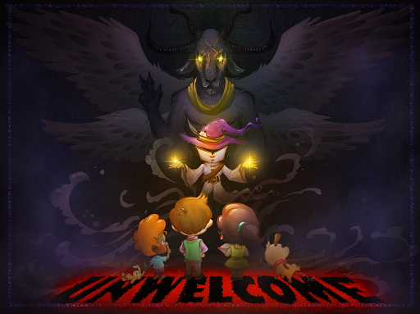

UNWelcome Game Design Document
Version 1.0

Position Title | Name | Signature
Stakeholder | Wendy Despain
Game Design / Level Design | Blake Philley
Level Design / Production | Xia Hua
Programming | Emily Rizzo
Art | Alexandra Copenhaver
Art | Clayton D’mello

Document Revisions Table
Version | Description | Requestor | Date
1.0 | Initial Document | Despain | 11/27/2017
1.1 | Edited formatting for easier reading, adding in gifs

Table of Contents
Concept 5
High Concept 5
Elevator Pitch 5
Loops and Pillars 5
Gameplay Loops 5
Pillars 6
Game Description 6
Game goals and Features 6
Context 7
Style and Tone 7
Player Skill Flow Chart 7
Gameplay 7
Key Game Features 7
Neighbors 7
Demons 9
Gameplay basics 11
Resources 11
Conveyance 12
Menu Icons 13
Gameplay Minute 13
Level Design 13
Legend 13
Tutorials 14
Tutorial 1 Layout 14
Tutorial 1 Flow 15
World Layout 15
Tutorials 15
Tutorial 1 Flow 15
Tutorial 2 Flow 15
Tutorial 3 Flow 16
Production 16
Risks 16
Production 16
Game Design 16
Technology 16
Art 16
Target Audience 17
Target Individual [2] 17
Target Demographic 18
Player Type 18
ESRB Rating 18
Trello Link 18
SCM Link 18
Art 19
ART DESIGN CATALOG PDF 19
Environment 19
Character Concept 21
Summoning animation 24
UI Framework 25
References 34
Internal 34
External 34
Player Feedback Link 34
Archives 34
Original mindmup 34
Change Log 34

Concept

High Concept

Elevator Pitch
UNWelcome is a turn-based tower defense, puzzle game where you play as a suburban witch who is keeping her friendly neighbors away - not by killing anyone, but by summoning demons.

Loops and Pillars

Gameplay Loops
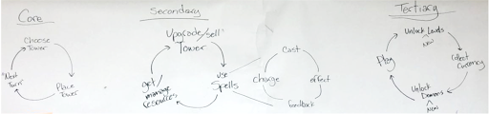
[1]
Core Loop (per turn) - Choose Tile -> Place Tower -> Hit "Next Turn" button
Secondary Loop (per level) - Consider Strategy -> Sell towers -> Place new towers -> get/manage resources
Tertiary Loop (per game) - Unlock new levels -> Play

Pillars
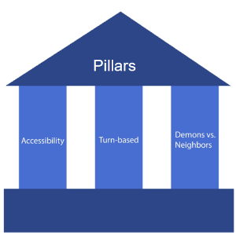
[1]
Pillars of the game:
- Accessibility: The player shouldn’t feel overwhelmed or frustrated playing the game. Mechanics should be easy to pick up and fun to play with, and the art style of the game shouldn’t be upsetting or graphic.
- Turn-based: Meaningful actions by the player should be centered around the turn based structure. The player should be able to predict what will happen in the next turn and make decisions around that.
- Demons vs. Neighbors: The gameplay and art should make a distinction between the witch’s ‘side’ (magic, demons, summoning) and the neighbor’s ‘side’ (annoyingly friendly, colorful, intrusive).

Game Description

Game goals and Features
UNWelcome is a turn-based tower defense game with many puzzle elements. In UNWelcome, you play as a suburban witch who is overwhelmed by her overly friendly neighbors. The player's goal is to kick neighbors out of the witch's house by summoning demons, which move neighbors around the space in different ways. Players must strategically place demons to push, pull and spring neighbors out of the house before they reach the witch. In UNWelcome, players can summon any number demons using their energy.
There are three different demons available to the player: Baphomet, who pushes neighbors in a straight line, Maalik, who springs neighbors over small obstacles like desks or couches, and Tamamonomae, who attracts neighbors to the tile she is summoned on. The range of functionality gives players the freedom to find different solutions for any given level, and experiment with different demon combinations.

Context
In UNWelcome, the player plays as an introverted witch, who has moved to suburbia. Overly friendly neighbors keep coming into her house uninvited, and to find some peace and quiet, she must kick them out. She summons demons around the house to forcibly remove the neighbors, but summoning demons drains her energy. If the neighbors reach her, the witch will have to interact with them, which will also drain her energy. The witch aims to throw all her intruding neighbors out of her house, and enjoy some time to herself.

Style and Tone
(Write one paragraph describing the look and feel of the game)

Player Skill Flow Chart
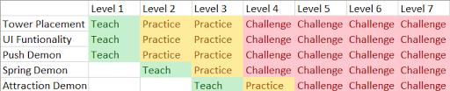

Gameplay

Key Game Features

Neighbors
Neighbors come into the house in waves, and make their way through the house towards the witch. If they reach the witch, the player will lose energy. If the player runs out of energy (health), they lose the level and must retry in order to continue playing.
Neighbors can be moved around the house by demons. If they are pushed onto an exit tile (a window, the front door, a drain, etc.), they are kicked out of the house for good. Neighbors cannot be moved through obstacles but can be moved over them.
Neighbors can be affected by other demons while still being moved by the first demon. For example, if a neighbor is pushed by a push demon, they will move 5 blocks. However, if at the third block there is a spring demon, the spring demon's effect takes over once the neighbor reaches it (while the neighbor is still being moved by the push demon), and the push demons effect will have stopped. The spring demon then throws the neighbor.
Figure 1 Double Click to view the animated portion of the gif
Neighbors have predictable movements and don't vary too much. Players can view the neighbors’ movement range by either long pressing on the neighbor icon or switching on the range indicator toggle on the top left of the side panel. (See page: XXX)

Mechanics
All neighbors move in the same way. Neighbors move 3 tiles per turn and will find a new path to the witch if they are thrown off the main path. If a neighbor is affected by a demon, their turn will end and they will not move after the demon's affect is finished.

Feedback - Path
The neighbor’s main path to the witch has a lighter tone than any other tile on the screen. This shows the player the path all neighbors follow to being with.
When a neighbor gets pushed off the main path, they calculate a new path back to the main path. This temporary path will be shown similarly to the main path, with a more transparent version of the main path’s lightness. This will disappear once the tile has been traversed by the neighbor.

Feedback - Movement
Feedback while the enemy is moving will be largely handled on a per turret basis.

Feedback - Firing/Range/Animations
Demons use colored X's to denote their activation range. X's are placed on the demon’s activation tiles. There is also a bullseye mark denoting the final tile that the neighbor will be moved to. Chevrons point from the activation tiles to the target tile, to denote every tile the neighbors will pass through. Pull demons activate on every tile marked with a chevron.
These range indicators are only present while the player taps and holds on top of the demon, or when the player has turned on the "Show all indicators" button on the side panel.
Push demon Feedback - Arrow particles, demon animation
Spring demon feedback - the neighbor is increased in size while thrown, and goes back to normal size when the throw is over, demon animation
Attraction demon feedback - The demon glows pink when firing. Neighbors have bright pink hearts popping up around them while they're being moved.

Demons
Demons are summoned by the player at in between turns, and are used to move neighbors out of the house. Each demon has a unique effect. When the player places a demon, they should be thinking "This is the correct piece I need to complete my setup" not "Well, I'll pick this demon because it can do the job." There should a clear feeling of "This decision I am making is important to my overall plan and goal."
Each demon has a cooldown for its effects. This cooldown recharges by 1 every time the enemies make a movement. (Enemies moving 1 tile = 1 movement). Enemies being moved by demons does not affect the demon cooldown. This cooldown will be described as "steps" - if a demon has a cooldown of 3 steps, the demon will recharge once enemies have moved through 3 tiles.
Neighbors do not collide with demons. The neighbors can walk through the demons.
Player can sell the demon and regain energy by tapping on the demon and then tapping on the sell button.
Player can adjust the demon's rotation by tapping on the demon and then tapping the rotate button.

Push Demon
Pushes neighbors in a straight line up to a maximum distance of 5 tiles in the direction it is facing. Cannot push neighbors through obstacles, but can push them very far across open terrain.
Range: 5 (enemies are pushed 5 blocks. They stop if they hit an obstacle, and are removed if they hit an exit) Activation Range: The tile it is placed on and 1 tile in front of it (in the direction it is facing) Cooldown: 3 steps

Range Indicator
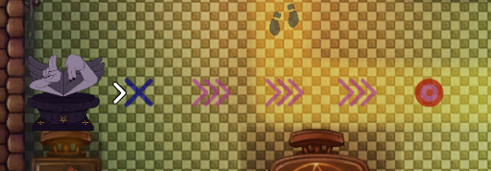

Spring Demon
Throws neighbors in the direction it is facing, completely over a single tile. Can be used to throw neighbors over obstacles. Spring towers can only launch over obstacles 1 tile long. Anything >1 long as an obstacle, the enemy will be dropped on the side the turret is on.
Range: 3 (the activation tile is counted as part of the range.) The 3rd tile (the landing tile) is the only one the thrown enemy contacts with. The enemy can be thrown over obstacles. Enemies can still be affected by other demons while being thrown, and will still exit if they are thrown "over" an exit tile. Activation range: The tile it is placed on and 1 tile in front of it (in the direction it is facing) Cooldown: 3 steps

Range Indicator
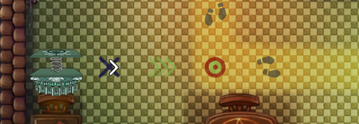
Figure 3 test caption

Attraction Demon
Pulls neighbors within a range towards it. When the neighbor reaches this demon, it will realize it has been charmed and continue moving towards the witch. All enemies in range are pulled when the tower activates.
Range: 4 (Enemies are pulled until they are on top of the demon and then stop.) Activation Range: 4 (The activation range is a line in front of the demon) Cooldown: 6 steps

Range Indicator
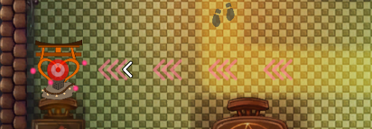

Gameplay basics
Neighbors cannot move through obstacles (walking, pushed, pulled), but they can be moved over obstacles (spring).
Neighbors find a path to the witch and the player loses energy if the neighbor reaches the witch. Energy is spent to summon demons. Neighbors can walk through demons.
Demons have specified activation tiles and a specified range. The demon only activates if the neighbor passes over the activation tile(s). Each demon's activation tiles are described in the section for the individual demons.
Each level is played in a wave mode. If the player completes all the waves they have beaten the level.
Each neighbor removed increases the player's score value and returns energy to the player.

Intended gameplay style
We want players to be creating solutions in the level, and then replaying the level to see if they can make a better solution than their previous attempt(s). Players should be enabled to easily edit their solutions to the levels.

Neighbor paths
Neighbor paths are denoted to the player in two ways:
The main path (from the front doors to the witch) are lighter than surrounding tiles, and are always visible to the player.
The temporary paths neighbors use to get back to the main path are have a light pink overlay. These temporary paths are only visible while the enemy is moving back to the main path. The temporary path overlay disappears once the neighbor walks through the tile.

Turn System
UNWelcome uses a turn system in its gameplay. Enemies can only move and be affected during the enemy's turn, and players can only summon demons during the player's turn. The turn only advances once the player pushes the next turn button.

Resources
There is one resource in the game: the player's health (referred to as energy).
Players spend energy to summon demons, and can regain energy by moving enemies to the indicated locations. (The removal locations: windows, chimneys, and trapdoors)

Conveyance

Demons
Demons convey their states using color change, sounds, and particles.
When firing each demon creates a sound effect and spawns a particle system. This signals to the player that the demon has activated.
After activating, the demon and its directional indicator are overlayed with a gray color The demon also has a small circle next to it to show its cooldown, which only appears while the demon is recharging. Each step the neighbors take reduces the pie chart until it is gone. When the pie chart is gone the demon is ready to fire, and it will return to its original color. The demons targeting range can be viewed by the player by pressing and holding on the demon. This shows the player the demon's possible range. Chevrons appear to indicate direction, and a target appears to indicate where the neighbor will be pushed to. These icons can also be displayed by turning on the "toggle all indicators" button.
Demons use a different color palette than neighbors (darker colors rather than brighter ones.) Each demon's color palette is unique, and the small icons correspond to the larger images that are shown on the right of the screen in the HUD.

Neighbors
Neighbors use very bright, pastel colors to stand out from the background and the demons.
When neighbors are being moved they are affected in different ways depending on which demon triggers on them: If the neighbor is pushed or thrown into an obstacle, a small cloud of arrows appears in the direction the enemy is moving. If a neighbor is being thrown, they will become larger while being thrown, to help convey that the neighbors are being thrown over obstacles. While being pulled, a small particle system spawning hearts will signify that the neighbor is being attracted to the pull demon.

Health/Resource
The player's energy is used as a resource for building turrets. When energy is spent on a demon a small red number with a minus sign appears above the player's energy bar. When energy is gained by removing enemies, small green numbers with a plus sign appear above the player's energy bar to signify energy gained. The player's energy bar is then updated. These numbers fade out over their lifetime.

Exits
Exits are conveyed to the player by using the color yellow and animation. The bright colors of the exit locations contrast with the dark tones of the environment which cause the exits to stand out. Small idle animations for each exit type draw the player's attention to these tiles.

Menu Icons
Symbols are used to communicate what each menu icon does.
A gear for settings. A Forward facing arrow for next turn. A Magnifying glass with a indicator chevron for toggling all indicators on and off. A heart in a jar of green liquid shows the player's health. The jar empties as the player loses health.
[CUT] A double arrow for auto-playing turns.

Gameplay Minute
(The storyboard and narration describing the average player experience) After loading into a level, the player looks at the layout of the level, and places demons around the house in a configuration that they think will be effective. The player might turn on range indicators, or click and hold on specific demons, if they want to be certain that their configuration will work as expected. The player will hit the next turn button to watch their plan in action. Neighbors will be affected by the demons, and some will be kicked out of the house, thanks to the player's strategy. When the turn ends, the player will evaluate their configuration, and might choose to place more demons or reposition some demons to deal with more of the oncoming neighbors. As their configuration of demons becomes more effective, the player might spend less time planning between turns, and will progress through the remainder of the level more quickly. When there are no more incoming neighbors, the player wins the level.

Video
Link to the gameplay video: https://youtu.be/HbjIcK5Bskw

Level Design

Legend
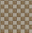
This is an empty tile. Players can summon demons on this and neighbors can path over it and be moved over it by any demon.

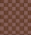
This is the neighbors main path. Neighbors will move along this path until they are moved off of it by a demon. (For more information on neighbor pathing see page: XXX)

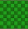
This is the neighbors beginning tile. Neighbors spawn from here.

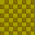
This is an exit tile. Neighbors will be removed if they touch this tile.

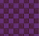
This is the Witch tile. The neighbors are trying to reach this tile.

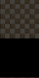
These are obstacle tiles. Neighbors cannot be moved through these tiles or path through these tiles. Only a spring demon can move neighbors over these tiles.

The blue space is space being used for the background art.
The layout tiles are used only in code. These tiles are not visible to player but they do determine what the neighbors and demons interact with and move around. The art is placed over the layouts. (See Page: XXX for more detail on art assets)

Tutorials

Tutorial 1 Layout
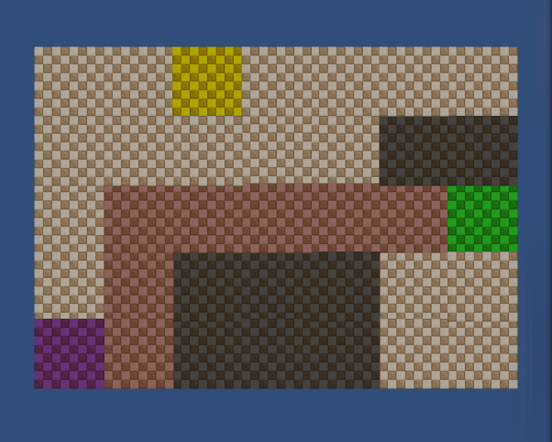

Tutorial 1 Flow
Tutorial 1 is a hand-held experience. Players are walked through all the necessary steps to learn the following skills:
- Neighbor Movement
- Turn Functionality
- Demon Summoning
- Push Demon Mechanic
- Spending Energy and Gaining Energy
- Waves
These are the steps players go through in this tutorial:
- The tutorial begins and a neighbor appears
- Players are told to remove the neighbor
  - In this step players are taught how to summon demons and what an exit looks like
- Players summon a push demon
- Players tap next turn and watch the neighbor be removed

Tutorial 1 Final Art
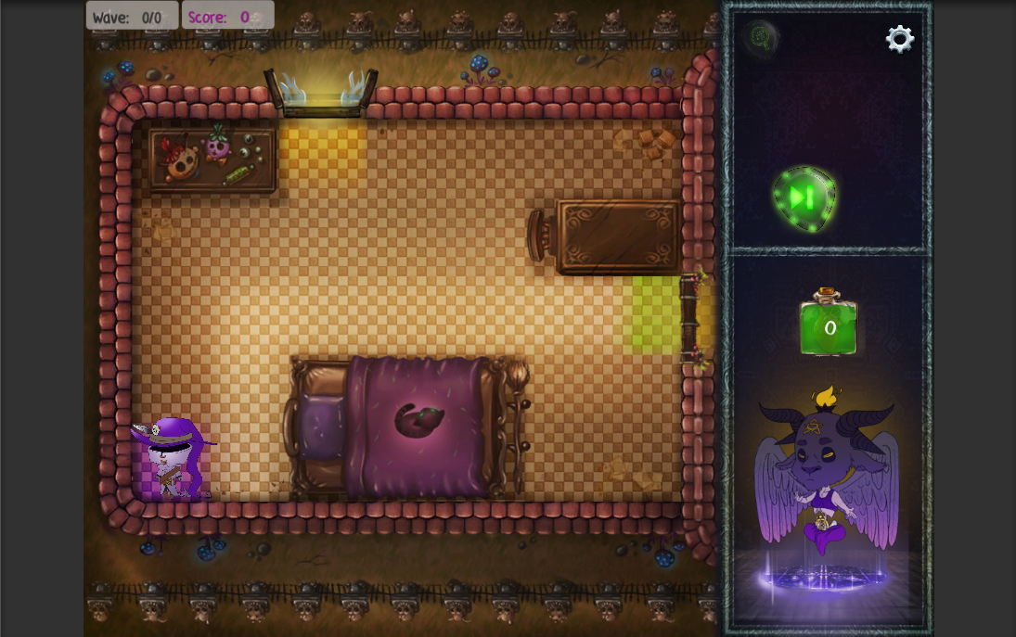

Tutorial 2 layout
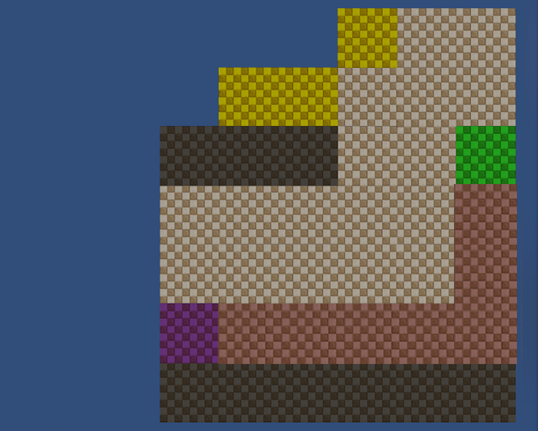

Tutorial 2 Flow
Tutorial 2 is also a hand-held experience. Players are walked through all the necessary steps to learn the following skills:
- Neighbors being pushed off the main path
- Summoning demons on and off obstacles
- Spring Demon mechanic
- Combining the demon’s effects to move the neighbors
- Demon cooldowns
These are the steps players go through in this tutorial:
- The tutorial begins and a neighbor appears
- The player builds a push demon and pushes the neighbor off the path
- The player then builds a spring demon and throws the neighbor over an obstacle and out of the house
- 2 more neighbors appear
- 1 neighbor is removed by the initial setup
- The player summons another push demon to deal with the second neighbor, the neighbor is pushed by this demon
- The player summons a spring demon on top of the neighbor to spring the neighbor over an obstacle and out of the house

Tutorial 2 Final Art
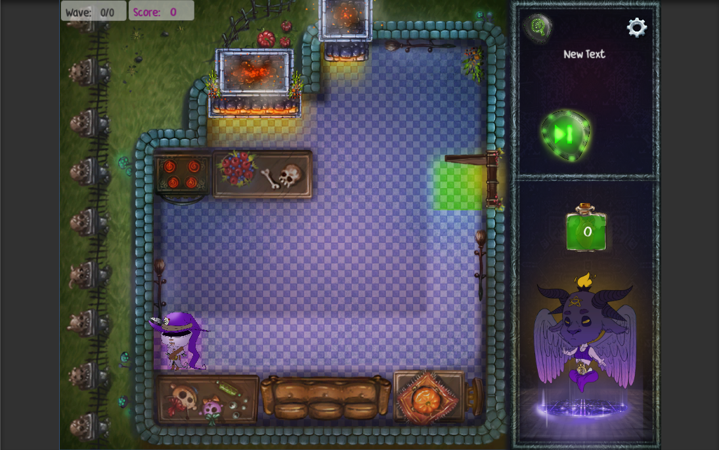

Tutorial 3 Layout
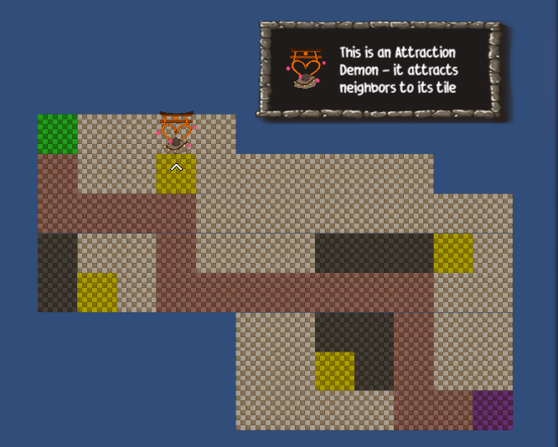

Tutorial 3 Flow
Tutorial 3 is similar to the "normal" levels, except a text tutorial explaining the mechanic of the attraction demon is present in this level. There is also a pre-placed attraction demon in the level to show how it works. (Extra Note: Level designers can pre-place demons in levels to teach players about demon functionality or for the sake of the level’s design. Demon summoning is normally handled at run time by the player but this functionality is built in as a feature for Level Designers.)

Tutorial 3 Final Art
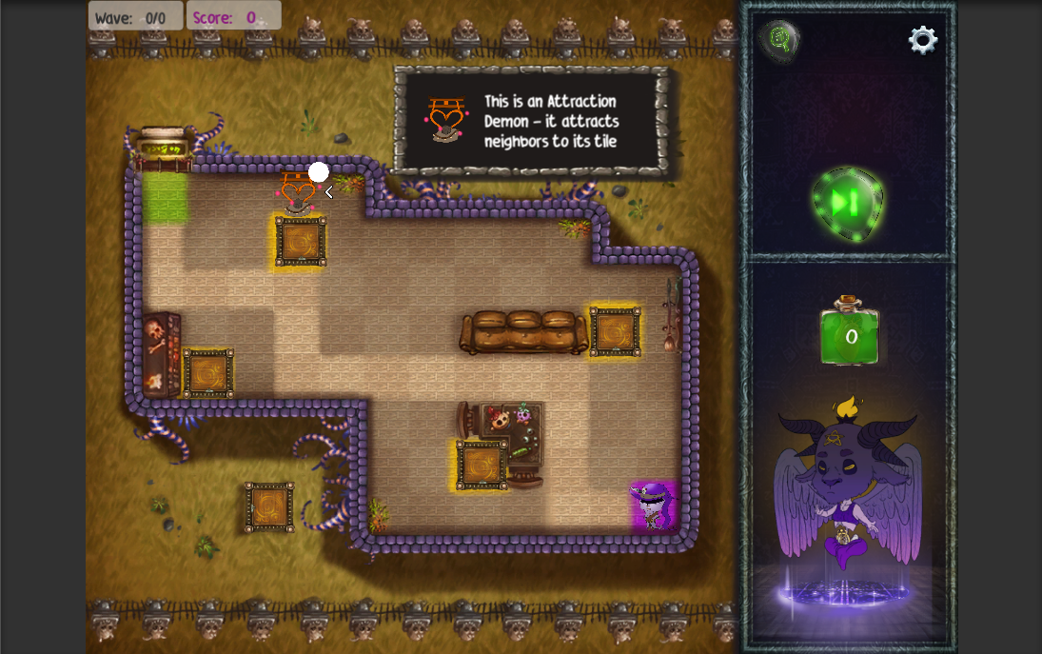

Levels
The non-tutorial levels don’t have a particularly defined flow. A focus of the core experience is the player’s ability to create and develop their own solutions. As such, players are intended to creatively solve the levels in front of them in whatever ways they can find using the tools available to them.

Level 1 Layout

Level 2

Level 3

Production

Risks

Production
We might be short of hand if any of the team members are sick or injured. Especially the artist and the programmer since no one else in the team could replace their roles.
We might have scope issues since the time and efforts of the team are affected by everyone’s other school work. Since we are not sure about each member's schedule there could be a situation that some of the team members need to work more on their own projects instead of the team project.

Game Design
The biggest risk of game design is whether the game designers could balance the in-game resources well to provide challenging and interesting gameplay. The game experience would suffer if the balance is poorly down and the player will feel the game either too easy or too hard and abandon the game.
Another risk of game design is whether the level designers could create enough fun levels to support the gameplay. We won't have a lot of time to iteratively playtest so finding the fun in prototype levels can be challenging.

Technology
The biggest risk in technology is the lack of experience. Only one of the 4 team members has the experience in developing games on Android platform. There could be unknown risks that the team could not foresee to avoid.
Another risk in technology is the performance issue. Since there will be multiple levels in our game. It is possible that the game could crash if it loads too many scenes and assets at a time. The team needs to do more tests to understand the limits of the device.

Art
The biggest risk in Art is the scope of work. In our game, there is great demand for art assets and the demand would increase as the development proceeds.
Another risk is the workload for the animation. We only did a simple testing on the mechanics of the animation but not a full test to cover all the possible usage of the animation in our game. It's difficult to estimate the workload for all the animation at this stage.
Demons will be represented by small icons, neighbors will be represented by a top down view of the neighbor. When either is clicked on, a pop up to the side will show the "fancy" art version of the selected item as well as the item's info. (Icon VS character)

Target Audience

Target Individual [2]
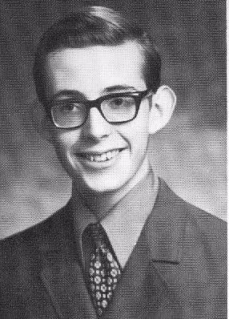
Is a freshman and goes to a college in a city far from his home. Takes a bus or train to school every day, he enjoys playing games during commuting. Loves to play strategy and puzzle games, but he only has fragmented time for playing due to his heavy work. Prefers relaxing and funny games, he plays most of his games on mobile devices. Familiar with slang and meme.

Target Demographic
Age: 16 - 30 Groups: Students, Young Adults, Casual Players Genre Preferences: Puzzle, Tower Defence, Adventure, Role-playing Install Base: Android Devices (Android version 4.3+)

Player Type
Our game appeals to Rational/Explorer type players. The core experience of the game is exploring mechanics to find solutions to the problem in front of the player.
The game also appeals to Achiever players who enjoy creating better solutions than what others (or themselves) have created in the past.

Explorer

Achiever

ESRB Rating

T for Teens

Trello Link
Link: https://trello.com/b/yUTy4Fhw/bleb-unwelcome If you need the permission to comment, please let the team know.

SCM Link
Link for editing: https://docs.google.com/spreadsheets/d/1RDju_4Vl_9yPNaSJyW2kIOO46sk_jwvWvuESzL0hURE/edit?usp=sharing

Art

ART DESIGN CATALOG PDF

Environment
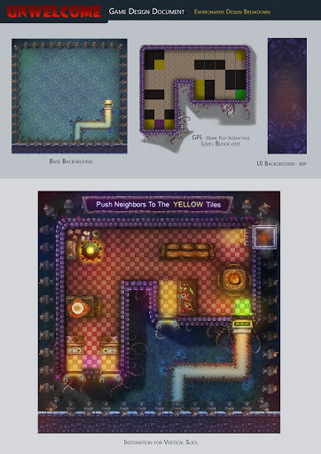
Environment is composed of tile sets that can be changed around to make each level look different from the next. Certain objects will be consistent throughout (torches, rugs, windows, etc.) There are wood floor tiles and ceramic tiled floors.
Different pieces of furniture will be made to correspond with the type of obstacles found in specific rooms. The obstacles are static and do not animate. They use a similarly dark color scheme as the demons and the environment. Examples include: Tables Chairs Armchairs Sofas Shelves Desks
Exits are bright pieces of the environment. They use a brighter color scheme to correspond with the neighbors. Exits are animated to bring the players attention to them. Examples include: Windows Bay windows Doors Chimneys Trapdoors
WALLS ARE CUT (Walls are placed to delineate rooms to the player. These walls are static and neighbors cannot be moved through them at all. Walls are shown with a black bar that has molding around the edges of it. Assets like paintings and torches are placed on walls to help convey to the player that it is indeed a wall. Walls can also be shown by running wires through them, or placing cobwebs and skeletons inside them.)

Design Datalog for Art
https://drive.google.com/file/d/0B4_csB2vev-uMXZGQmhVM0hDZHc/view?usp=sharing

Character Concept

Neighbors [1]
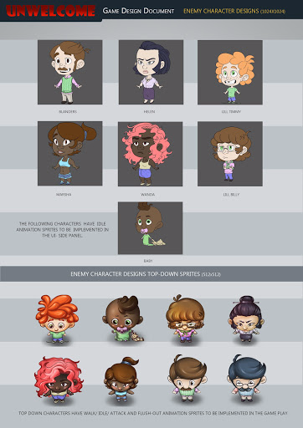
Icon Anims (256X256) ----- Character Anims (1024X1024) Move (4 frames) ----- Idle (8 frames) *** Move: walk;thrown;pushed;attracted Idle (4 frames) ----- Hit (4 frames) Attack (4 frames) ------ Attack (8 frames) "Death" (4 frames) ------- ?"Death" (4 frames)/?Move (4 frames)

Demons
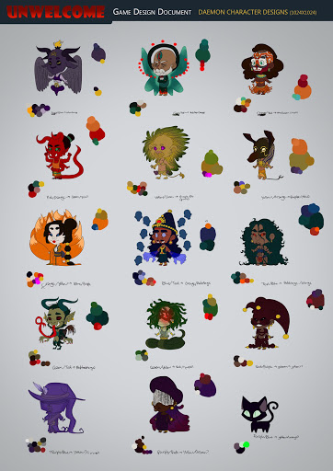
Icon Anims (256X256) ----- Character Anims (1024X1024) Idle (4 frames) ----- Idle (?8frames) Attack (4 frames) ----- Attack (?8frames) ?Replenish (4 frames) ----- ?Replenish (?8frames?)
- [1]
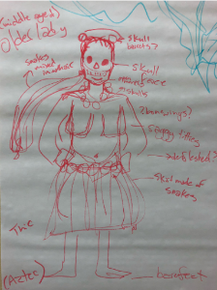
- [1]
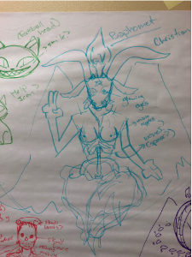
- [1]
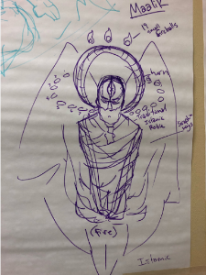

Witch
Icon Anims (256X256) ----- Character Anims (1024X1024) Idle (4 frames) ----- Idle(8 frames) Hit (4 frames) ----- Hit (4 frames) Death (4 frames) ---- Death (4 frames) ?Replenish? (4 frames) ---- ?Replenish? (8 frames) ?Summoning (4 frames) ----- ?Summoning? (8 frames) ?cheer animation (4 frames) -------- ? cheering animation -- when enemy death (8 frames)
- Cat
- Icon Anims (256X256) ------ Character Anims (1024X1024) Idle (4 frames) ---- Idle (4 frames) ?Replenish (4 frames) ----- ?Replenish (4 frames) ?Attack (4 frames) -------- ?Attack (4 frames)

Summoning animation
The summoning animation is played when a demon is summoned in the playing area. The big head art that corresponds to the demon summoned appears on the side of the screen while the player is selecting the demon and rotation. Once the rotation has been selected the big head moves towards the top of the active area of the side panel while shrinking. The demon icon then grows on the playing field and the big head grows back in on the side panel. The animation is then over and the demon is ready to fire.

UI Framework
Link to the UI framework: http://3ggcm9.axshare.com PSW: bleb
When placing demons, a small icon for each demon is placed next to the text outlining its functino. (Push, pull, or spring.) These small icons correspond to each demon specifically to give the player a visual connection for each demon and its function and button.

UI Interactions

Range Indicators
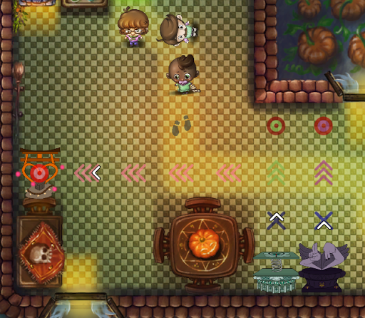
Figure 4: Range Indicators for demons and neighbors
Players can show range indicators by tapping the magnifying glass on the side panel or tapping and holding on individual demons or neighbors.
Blue 'X' - Shows what tiles the demon activates on, with the exception of the attraction demon. (The attraction demon activates on the chevrons)
Chevrons - These show what tiles the neighbor will be moved across
Bullseye - This shows where the neighbor will come to rest. The bullseye is slightly colored according to whichever demon type it is associated with. (Purple for push, green for spring, and pink for attraction)
Whichever demon was placed last draws its range indicators over the indicators of the other demons. The demon’s range indicators will stop at the end of their range. For example, a push demon has 5 total range. If there is an obstacle 3 tiles from the push demon its range indicator will only show 3 tiles instead of the total 5. This is visible in Figure 3 above. A push demon's total possible range is 5 but there are only 3 valid tiles in front of it.
Footsteps - These indicate where the neighbors will move along on the next turn. The demon targeting indicators draw over the neighbors' movement indicators. These are drawn below the demon range indicators.

Demon Summoning and placement

Demon Placement - Selection
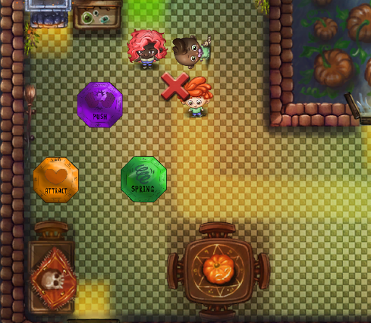
In order to place a demon players will:
- Tap the tile they want to place a demon on
- A popup will appear around that tile giving the player the option of building any of the 3 demons (Push, Spring, or Attract).
- Players will tap which demon they want to place
- Another pop up will appear showing some arrows. These arrows determine which direction the demon faces. Players will tap the arrow corresponding to whichever direction the demon should face.
- The summoning animation plays
- The demon is now ready to fire.

Demon Placement - Rotation
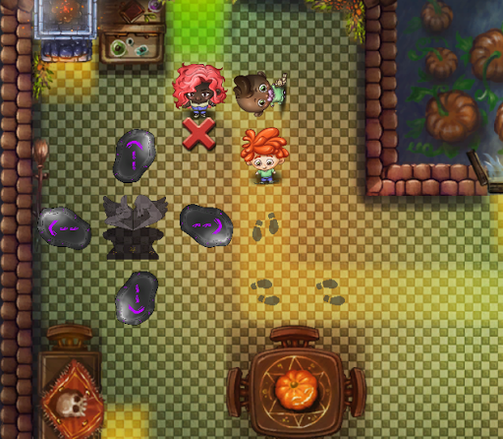

Interacting with demons
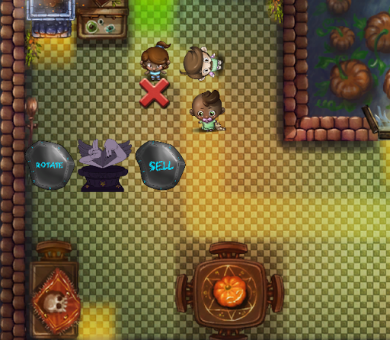
Players interact with existing demons by tapping on them. After the player taps on the demon a popup menu appears around the demon. This menu contains two options, rotate and sell. Rotate will allow the player to change the rotation of the demon and uses the same step as summoning the demon. Sell will return 75% of the energy cost used to summon the demon to the player and removes the demon.

Basic Rotation
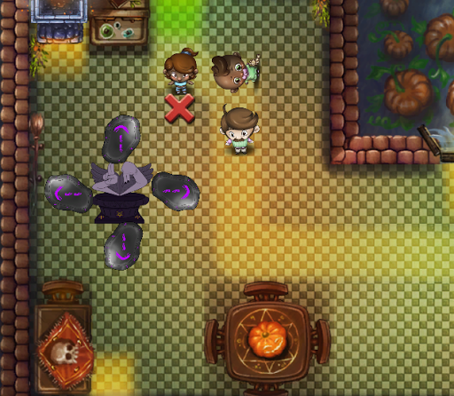

Attraction Rotation
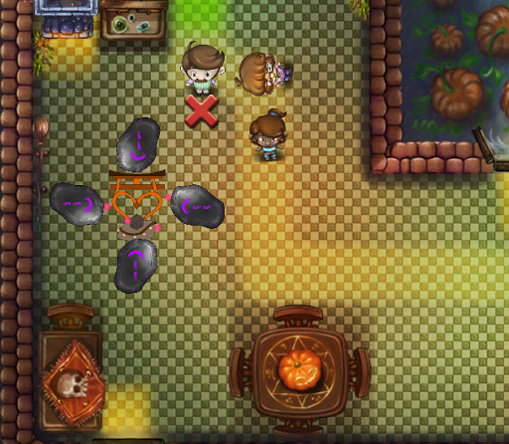
  - The arrows for the attraction demon are reversed from the other demons because the attraction demon moves the neighbors toward itself, and not away from itself.

General UI Info
A sidebar is present on the game at all times. This sidebar holds meta information about the game and menus. Final, larger character art is present here. Players can tap on specific enemies, or demons and receive more information about what was tapped on in the sidebar. (Demon cooldown, neighbor stats, demon characteristics).
Options, indicator toggle, and next turn buttons are present here as well.
Inside the options menu, the player can restart the current level, or return to the main menu,
The indicator toggle will turn all indicators for demon ranges/neighbor movements on or off.
The next turn button will begin the next turn when pressed.

HUD & Camera
The game uses a top-down view camera to show the full scale of the level. Players can use fingers to zoom in and out and can swipe to pan the camera.
HUD elements in the game: Health Bar: show the remaining health the player has. This is displayed as a glass bottle with a heart inside of it, filled with liquid. The more health the player has, the more full the full the bottle is.
Wave Number: Shows the remaining waves of neighbors in the level.
Score: show how many scores the player has gained. Score is gained by pushing neighbors onto exit tiles.
Pop-up art section: If the player taps on a demon or neighbor a larger picture of the tapped thing will show up in the sidebar. This larger view shows more detailed art and animations than the smaller versions on the playing field. Information about the demon/neighbor will also be displayed in the text area. Art still appears in the tutorial level, but the corresponding text is not displayed, due to the text area being used for tutorial text. Tapping on an empty tile will remove the art in a non-tutorial level.
Text Area: This area is used for tutorial text, and for displaying information about a demon or neighbor when the player clicks on it (on non-tutorial levels only). Tapping on an empty tile will remove text in a non-tutorial level.
- Side Panel
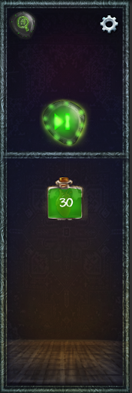
- The side panel is the location that holds all relevant meta data for players such as: Demon description Demon's attatch range Demon's cost of energy for summoning Player Energy Buttons (Next turn, range indicator, settings) Character art
  - Side Panel - Filled
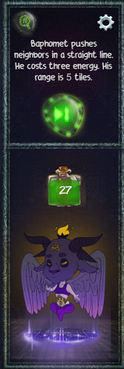

Controls
Players tap on the tiles to set up and manage the demons, tap on the demon icons to interact. Players tap the next button on the side panel to proceed the game Players tap on the indicator button to show all the demons attack range as well as the neighbors movement range, tap again to switch them off. Players use two fingers to zoom in and out to change the camera distance, use one finger to swipe to explore other areas in the level.
[CUT] Players can drag the spell icons from the sidebar and drop the icons to the tiles to cast spells.

References

Internal
[1] By Team

External
[2] [http://www.skepticblog.org/wp-content/uploads/sc00041f13.jpg](http://www.skepticblog.org/wp-content/uploads/sc00041f13.jpg) [3] [https://makeagif.com/gif/all-battleblock-theater-cutscenes-lv9DUM](https://makeagif.com/gif/all-battleblock-theater-cutscenes-lv9DUM)

Player Feedback Link
https://docs.google.com/document/d/1sICnulkMT9dRoxP9_h_Wpl6NYuCZ_tadRi46O0m5UGc/edit?usp=sharing
This links to a living document that records feedback from playtesters

Archives

Original mindmup
https://drive.mindmup.com/map/0BzxKve0xrqgMVm9NUTh3bmliRm8

Change Log
10/5 - Added in feedback nodes, summoning animations, and edited demon nodes. UI general tab added. Witch and cat tabs added to art. Neighbors and demons tabs updated with more info.
10/12 - Feedback link added and document created. Spring towers can only launch over one long obstacles. Anything >1 long as an obstacle, the enemy will be dropped on the side the turret is on.
10/13 - updated demon cooldowns. added conveyance section.
10/16 - added some clarification to demons and ui elements. added in a piece of reference art for neighbors.feedback from 10/16 kleenex test added to feedback doc and general info added to feedback doc.
10/19 - added tutorial section to world layout. added tutorial 1 flow.
10/22 - added playtest feedback from Zhi Yang
10/27 - edited demon activation ranges, demons can now activate on the square they are on. updated demon placement. LD's can pre place demons in levels. In the demon placement GUI there is a small icon of each demon next to the text that outlines the demon's function.
11/7 - updated gameplay loops, changed wording in a few locations (minor edits)
11/20 - updated obstacles, walls have been cut. added a bit more to summoning animation. changed some gifs out for static images. edited UI section.
11/21 - updated level progress chart, tutorial flows, neighbor mechanics, menu items, demon mechanics, general UI info.
11/22 - added a clarification to demon range indicators. the indicators stop at the last valid tile for a demon to be moving and enemy across. References to 'health' changed to 'energy' for consistency. removed gifs from demon section and added range indicator images. changed references to pull demon to attraction demon.

