# Mech n Tech

I’ve taken to calling what we’re going for ‘Mech n Tech’. It’s a high tech, futuristic world, but everything is working mechanically. Machines are important in this world, but the truly high-tech stuff is software. Mechanical systems are still recognizable to people from 2018 (I could still tell you what a hydraulic piston looks like) but the software is so advanced it’s almost alien.

Mech n Tech Examples:

## Pacific Rim

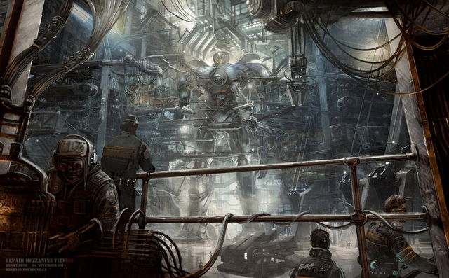

Pacific Rim is a great example of mech n tech. This world is extremely high tech, but everything functions mechanically, but the machines have expanded far beyond the scope of what we have available to us on Earth today.

Scale helps this feeling a lot, and Pacific Rim is an excellent example of this. The bigger the better as far as scale is concerned. The world should feel expansive. Civilizations and societies expand outward because space isn’t limited.

There’s a little bit of hologram-y stuff in this world, but we should push that further in our game. The software in this world isn’t far enough in the future. Imagine that the rate at which software is improved has far outstripped the rate at which machines have improved.

**Also, don’t do kaiju things**. We aren’t doing kaijus. Even if that would be awesome.

## Redline



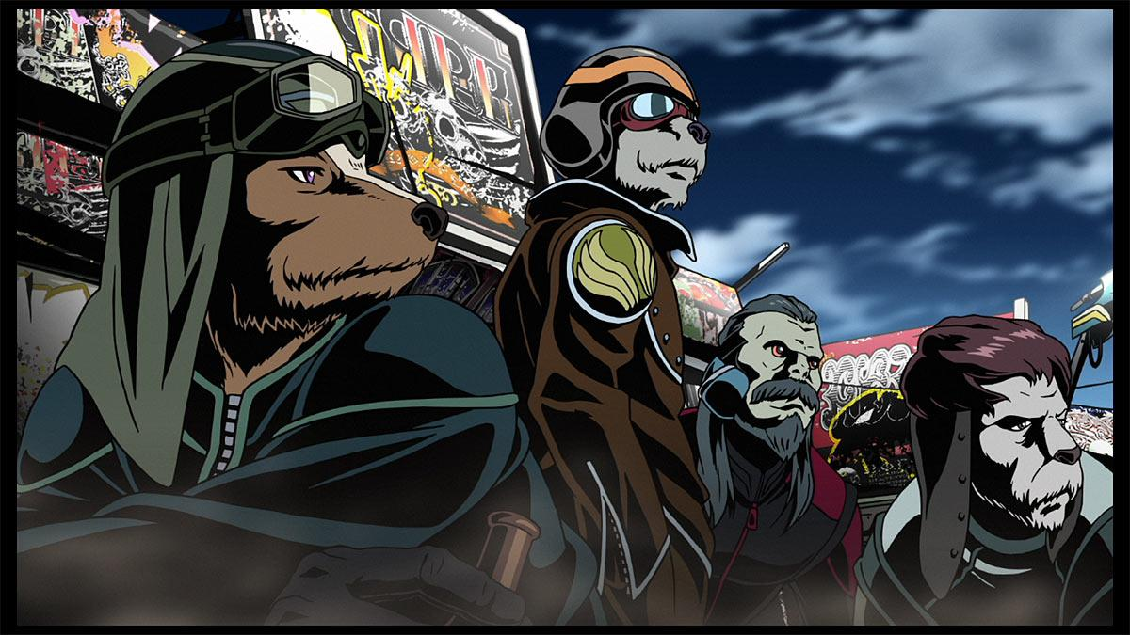

Redline is another great example of Mech n Tech. The future is high tech and crazy, but it’s still very mechanical. Always keep the mechanical idea in mind when building stuff. Almost like, less elven, more dwarven (to put this in fantasy terms).

Redline doesn’t have enough hologram-y stuff. We want more future-y than this, but still a mech focus.

Also very important from redline, machines aren’t just built for humans. Things that exist are built for lots of different alien races to use.

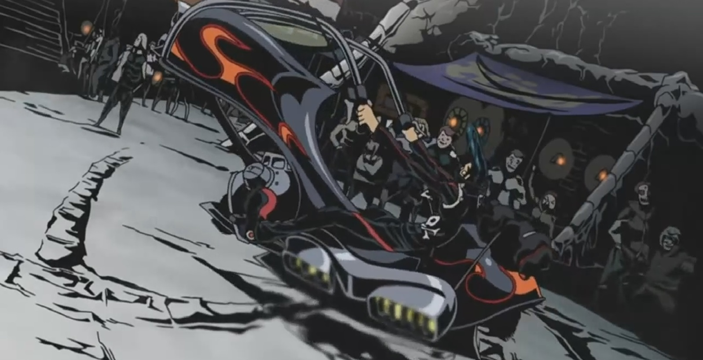

## 

## Warhammer 40k

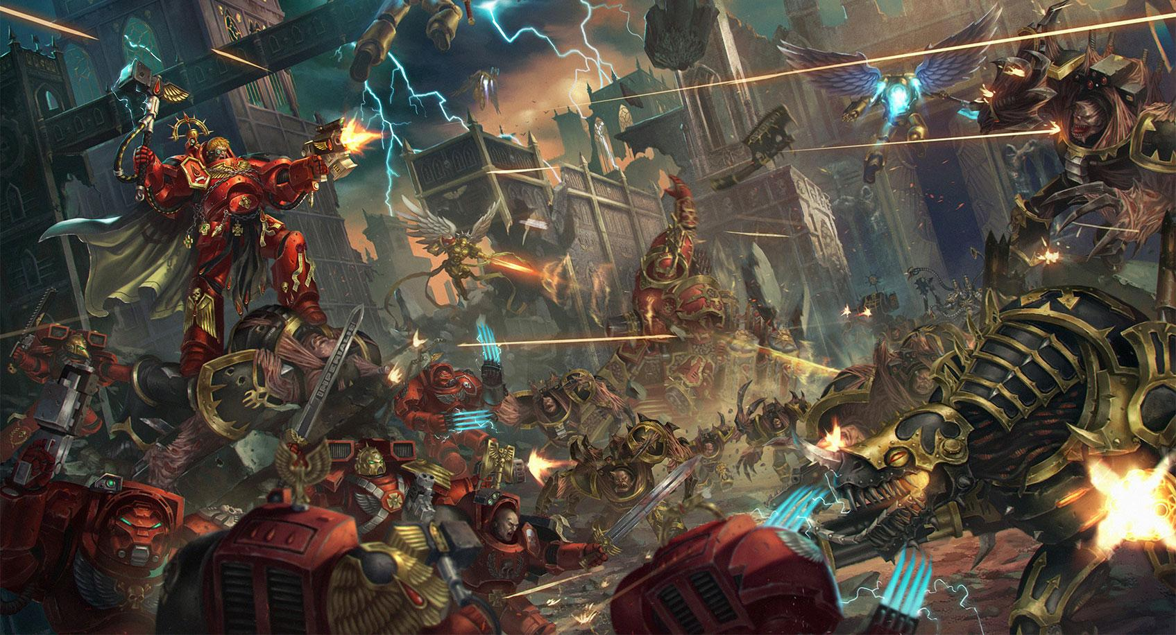

Warhammer 40k isn’t a great example because it’s a terrible world and that’s kind of the point of it..We want a more positive world and a more positive outlook on the future than this. But, 40k has a lot of high tech mechanical things in the world. Most of this world functions mechanically.

The dark tones of this world aren’t what I want you to look at, rather focus on the way technology and machines are handled. There’s crazy stuff like vibro-blades, attached to plate armor. What we’re going for is almost in the middle of high-tech and low-tech machines.

## Star Wars

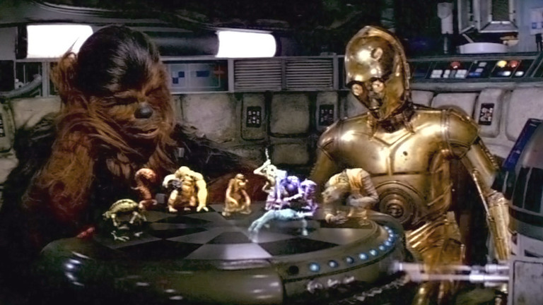Star wars is another great example of this. They’ve achieved faster than light travel but there are still basic machines. Everything feels sturdy and mechanical, but runs highly sophisticated software. Things like holograms are possible and happen a lot in this world.

The dejarik table from star wars is a really great, specific example of this. It’s basic looking, mechanical hardware, that runs and utilizes really cool software. Holograms are gonna do great for our game.

## 

## Starcraft 2 Terrans

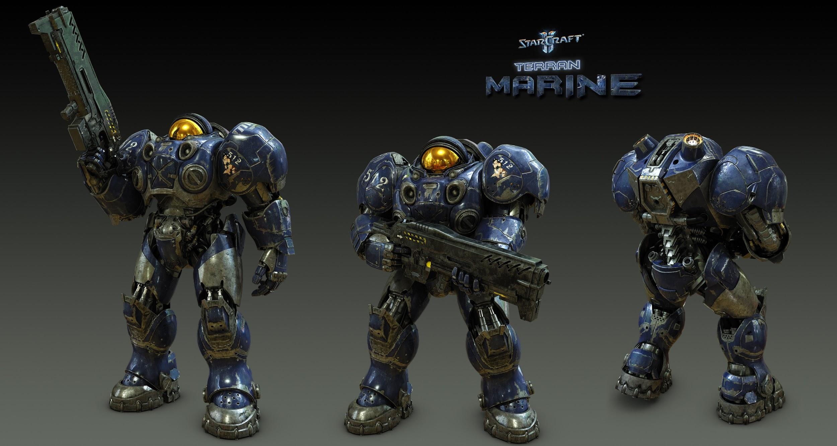

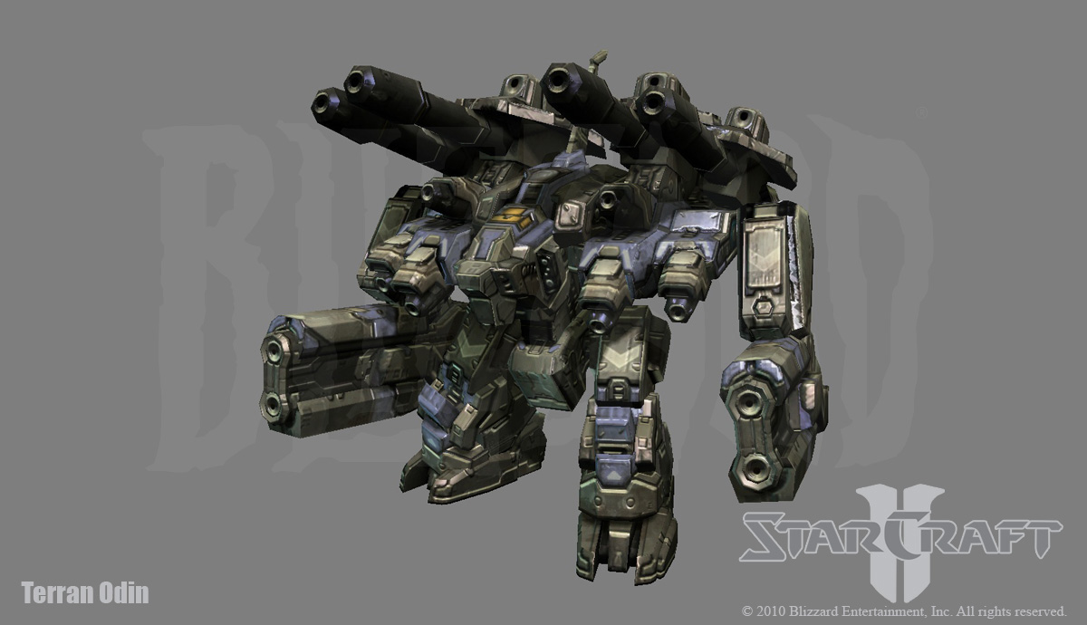

The terrans are another good example of complicated machinery, with high tech software running on it. Don’t look too much at the colors here, because the terrans are very drab. But the terrans have things like FTL, and hologram tech. But everything runs on straightforward machines.

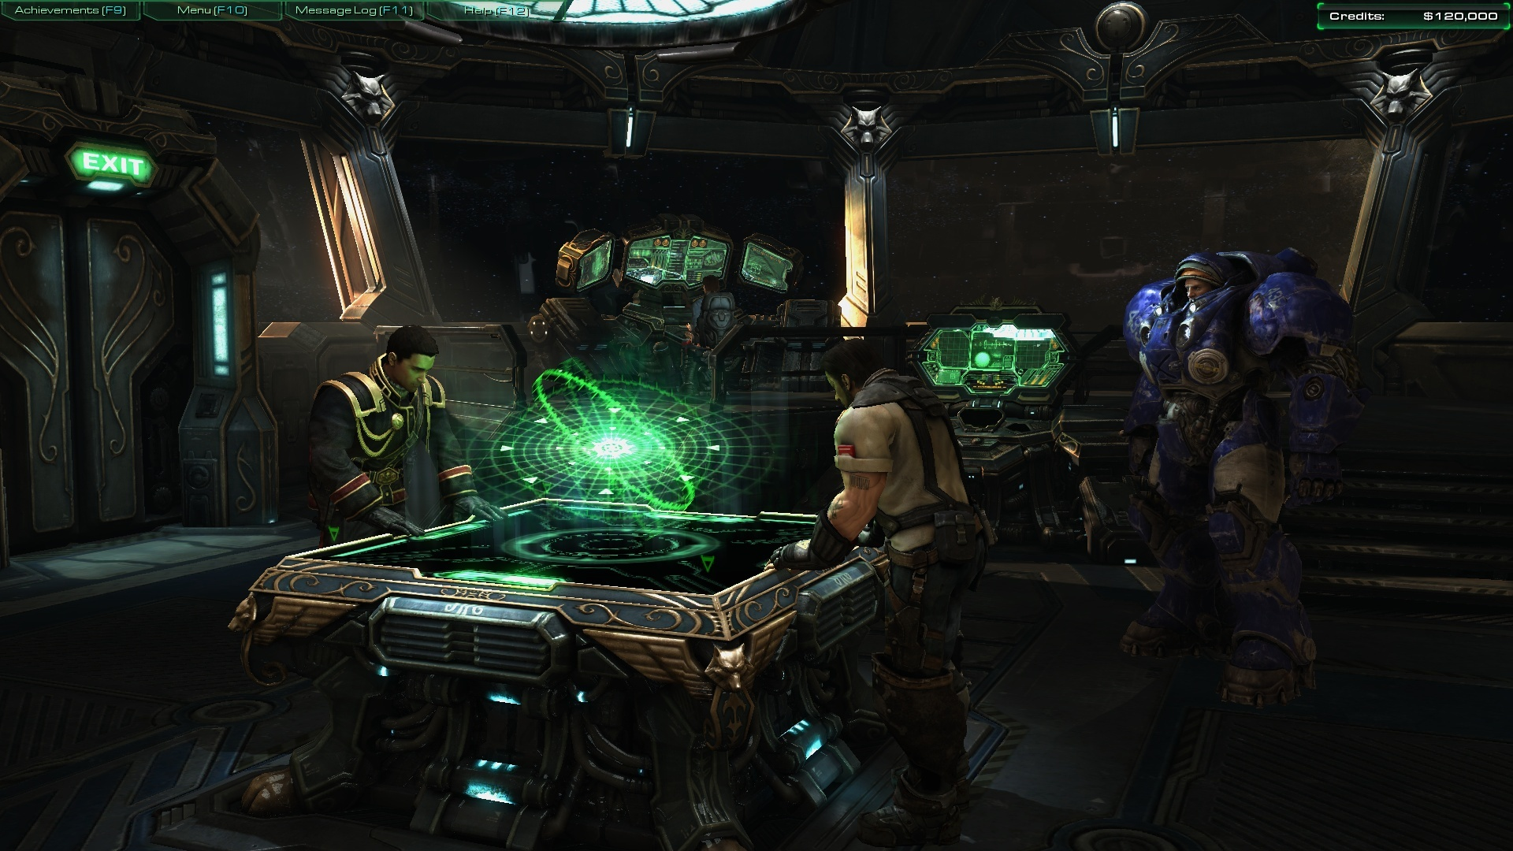

The Hyperion’s Bridge is a really great example of Mech n Tech as well. As a 2018 human I can kind of understand what the hardware is, but the software is completely new to me. Holograms are great and the colors are nice here. It’s a bit on the drab side, but there’s lots of color added in.

## Bladerunner

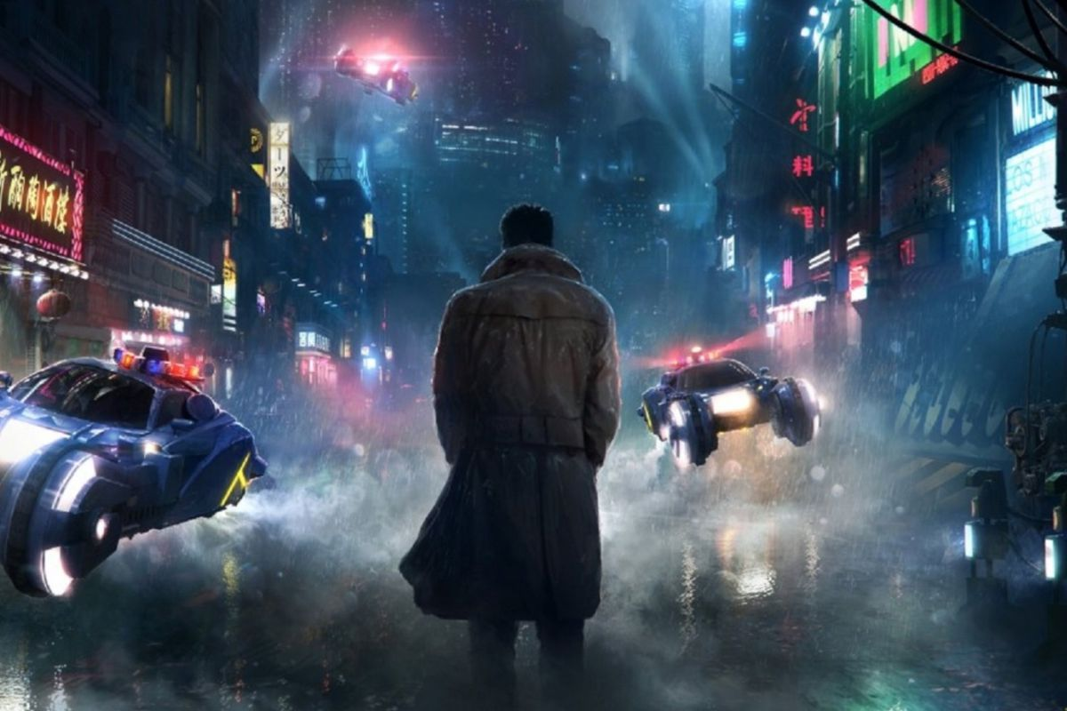

Blade runner’s neon signage is great. The colors are really nice with the signs here. I think we want more color though. Blade runner is very dark, and we want a brighter world and a brighter world outlook. Things like flying cars work great for this aesthetic.

Use lots of neon and bright colors. Also flying cars.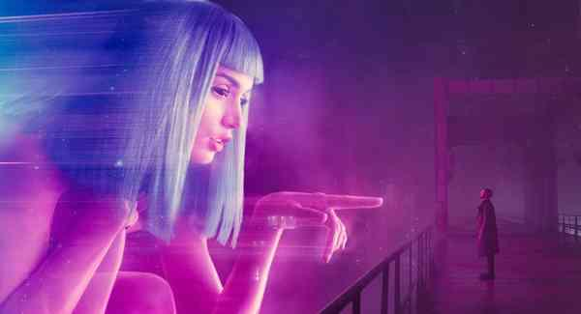

## Ghost in the Shell

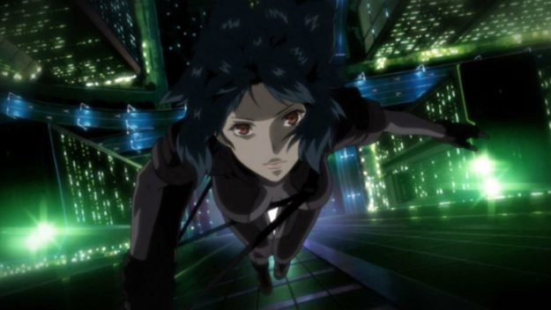

The color here is excellent. It makes the world appealing and interesting. The city feels so much better because of the brighter colors.

Cyborgs are a great thing to put into this world.

# General Guidelines

* We are not making a cyber future, tron is not a great example to look to
* Bigger is better for scale of environment objects
* Players should want to visit these places
* An important point to remember: this universe has near constant migration of all different alien races
* Hydraulic systems are still present
* They’ve achieved FTL and anti-grav tech
* I’ve been harping on about mechanical systems and machines a lot, but we can also break that somewhat. Use holograms, use floating thingies, use neon lights and signage
  + Having some advanced hardware can make this feel a bit more real. Hardware and software don’t improve in the same industries at the same rates
* Don’t make megacity 1 from Dredd. That is too dark and drab for what we’re doing. It’s also not high tech enough
* We aren’t making the jetsons either. That’s too 70s future, or like, 70s nuclear future
* All software has visible hardware it runs on to cement it in the world

# TL;DR

* The rate at which software improves outstripped the rate at which hardware and machines improves
* Neon is great
* Machines are still very important in this world
* The world wasn’t just built for humans
* Diverse alien races, and diverse stuff to support that
* Try to make stuff that doesn’t look like it would exist on earth. If you could see what you’ve created existing somewhere on earth, it’s too human and not future-y enough.
* Don’t think “The year 20XX” think, “The year 2XXX”
  + Hundreds of years is an extremely long time in terms of software. For software it may as well be thousands of years in traditional terms
  + Computers haven’t even been around in their current form for a century and we can make holograms.